ER Model – Dimension Model Analysis and Visualization

ER Model for Upwork

**ER Diagram snapshot:**

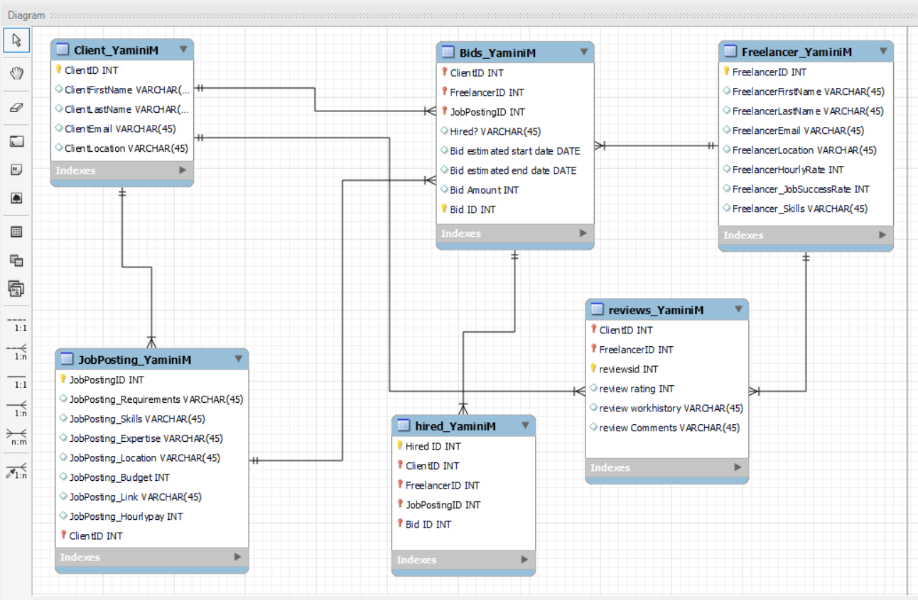

The ER Diagram contains of 6 tables where 3 are associate tables:

1. Client_YaminiM
2. Freelancer_YaminiM
3. JobPosting_YaminiM
4. Bids_YaminiM
5. Hired_YaminiM
6. Reviews_YaminiM

**Table1**: Client_YaminiM – This table has 5 entities and 5 attributes, primary key is ClientID and no foreign keys. Bids_YaminiM, Jobposting_YaminiM, reviews_YaminiM has relation with client_YaminiM table.

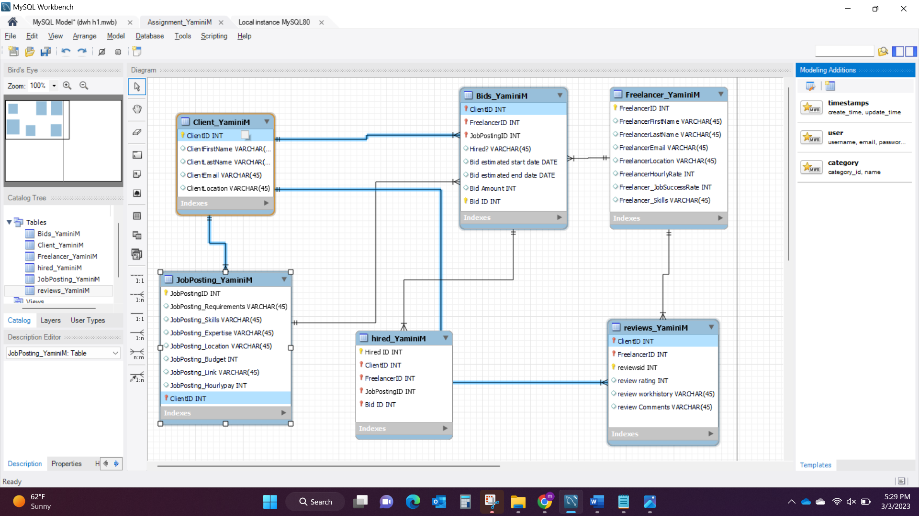

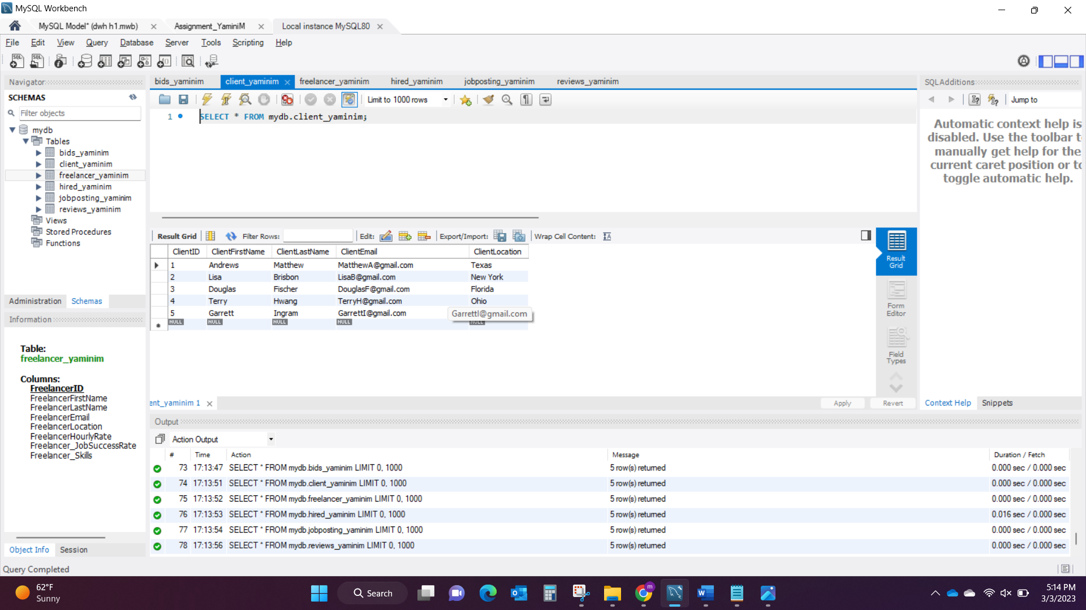

**Table 2**: Freelancer_YaminiM – This table has 8 entities and 5 attributes, primary key is FreelancerID and no foreign keys. Bids_YaminiM, hired_YaminiM, reviews_YaminiM has relation with Freelancer_YaminiM table.

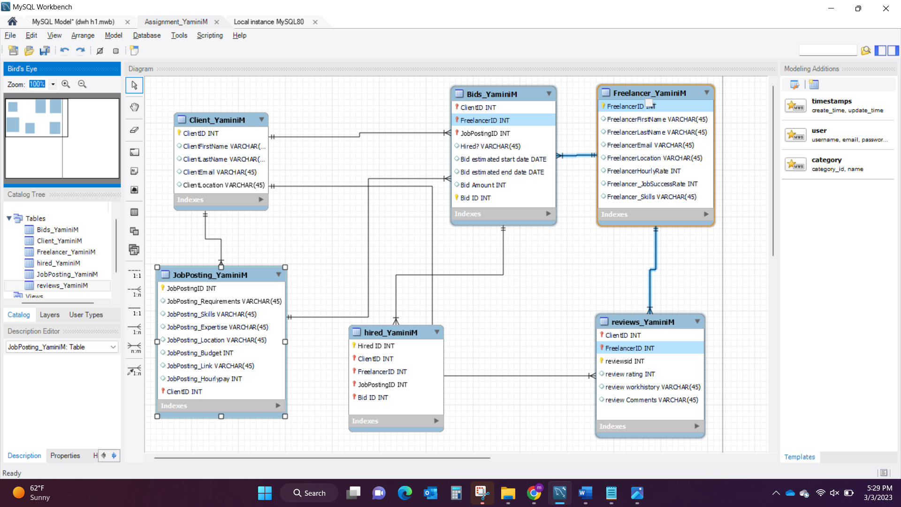

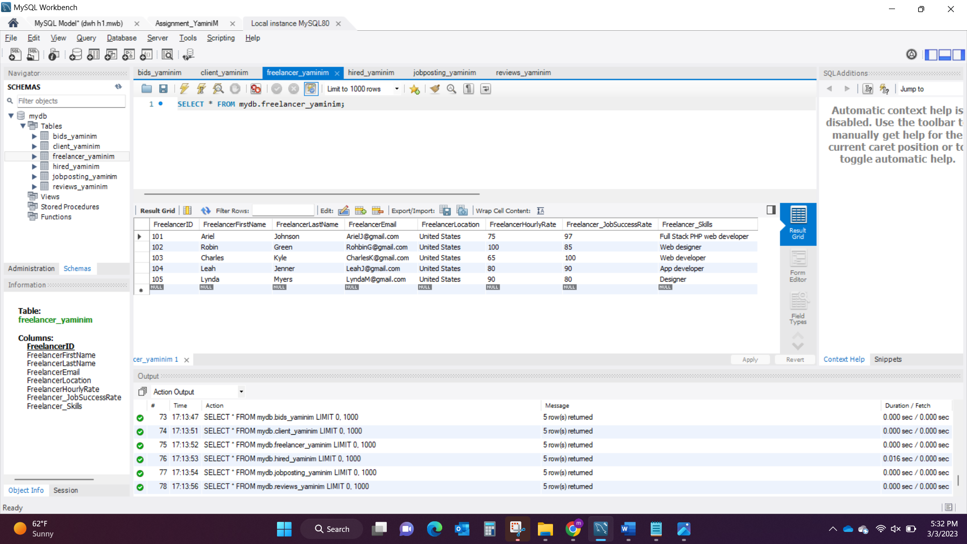

**Table 3**: JobPosting_YaminiM – This table has 9 entities and 5 attributes, primary key is JobPostingID and Foreign key is ClientID.

Client_YaminiM and Bids_YaminiM has relation with JobPosting_YaminiM.

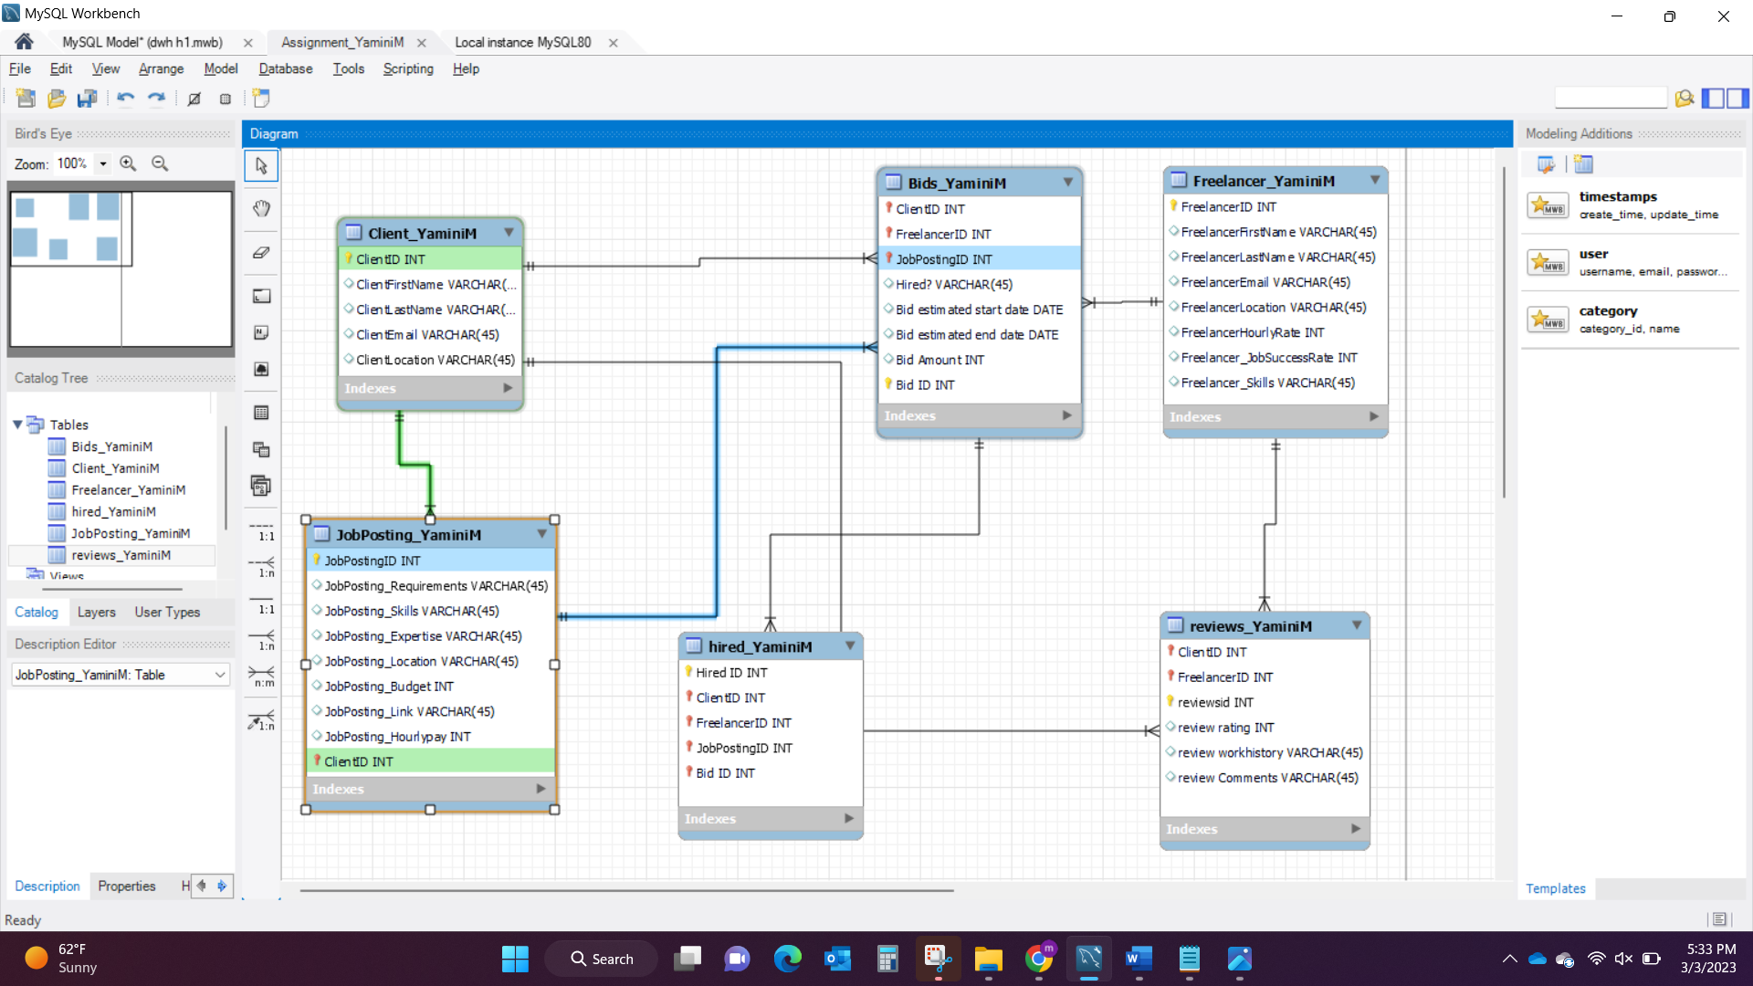

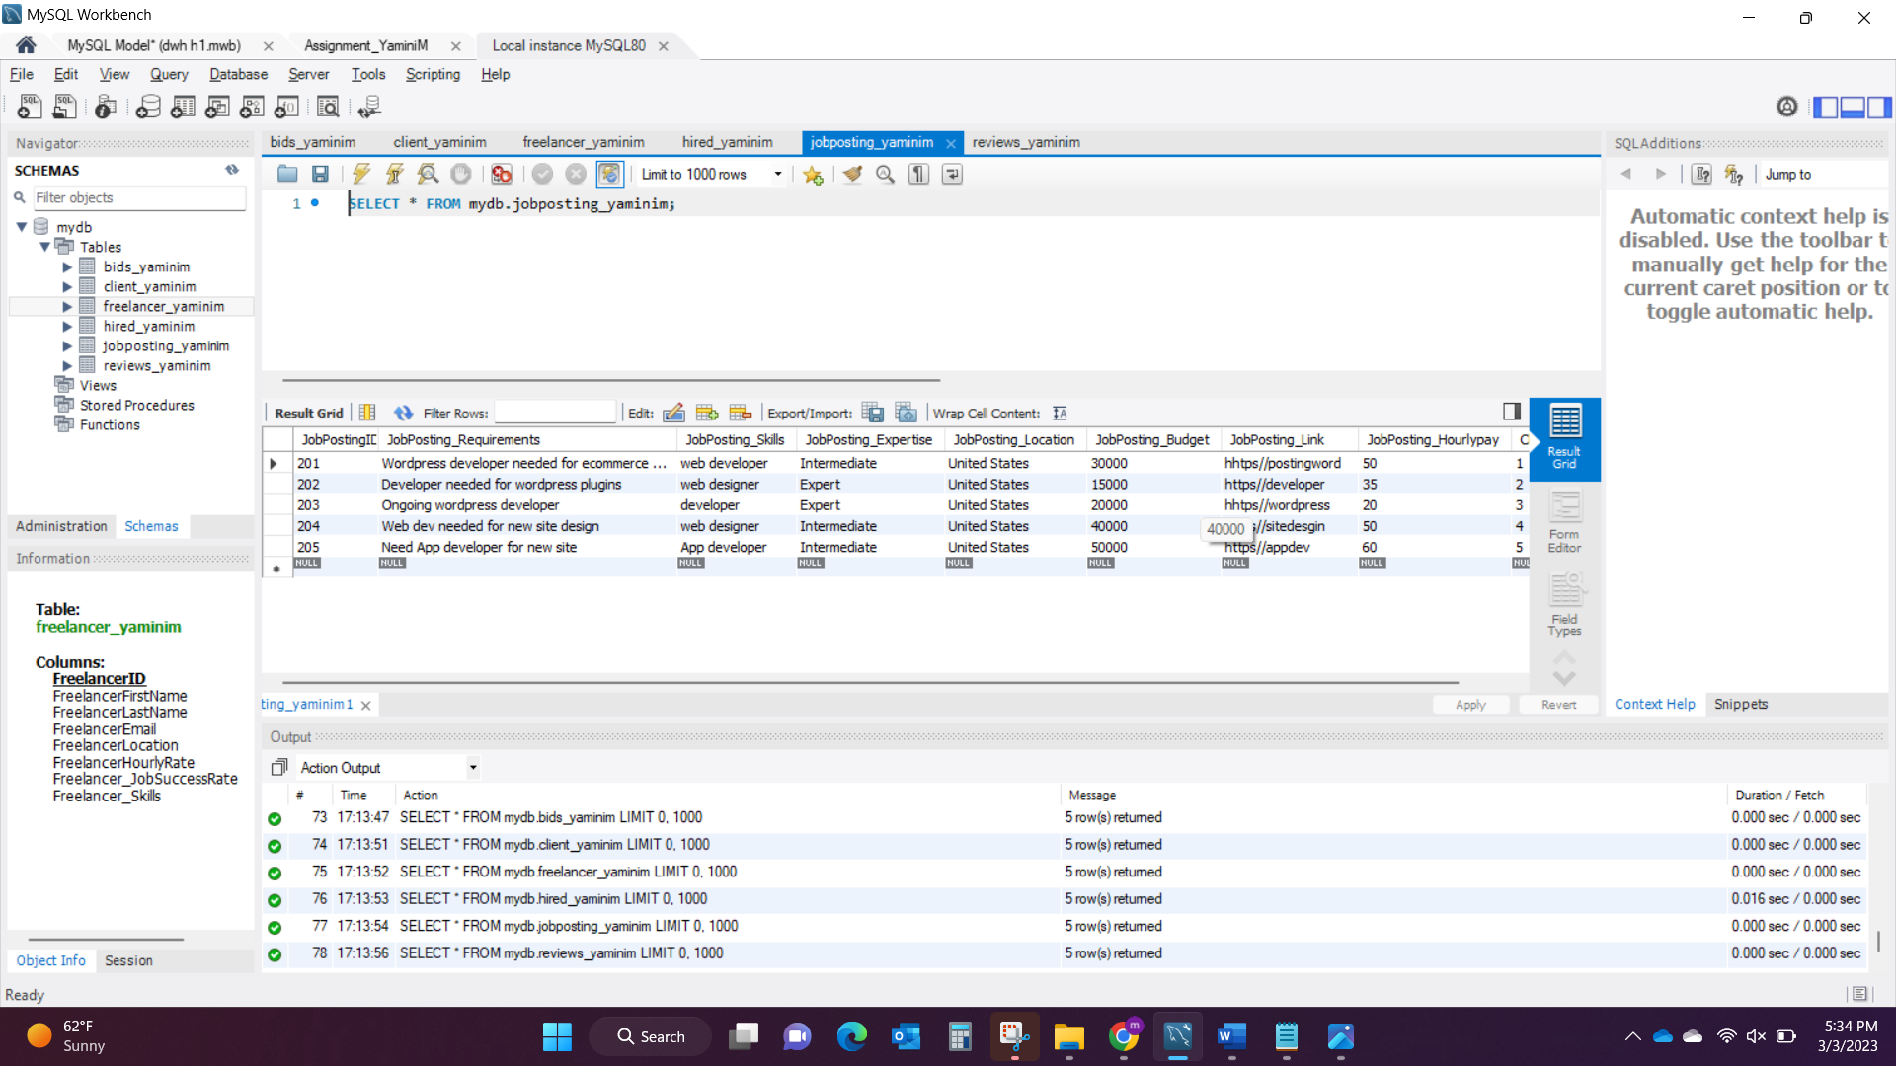

**Table 4**: Bids_YaminiM – This table has 8 entities and 5 attributes, Bid ID is the primary key, ClientID, FreelancerID, JobPostingID are the Foreign keys. This is an Associate table between Client_YaminiM, Freelancer_YaminiM and JobPosting.

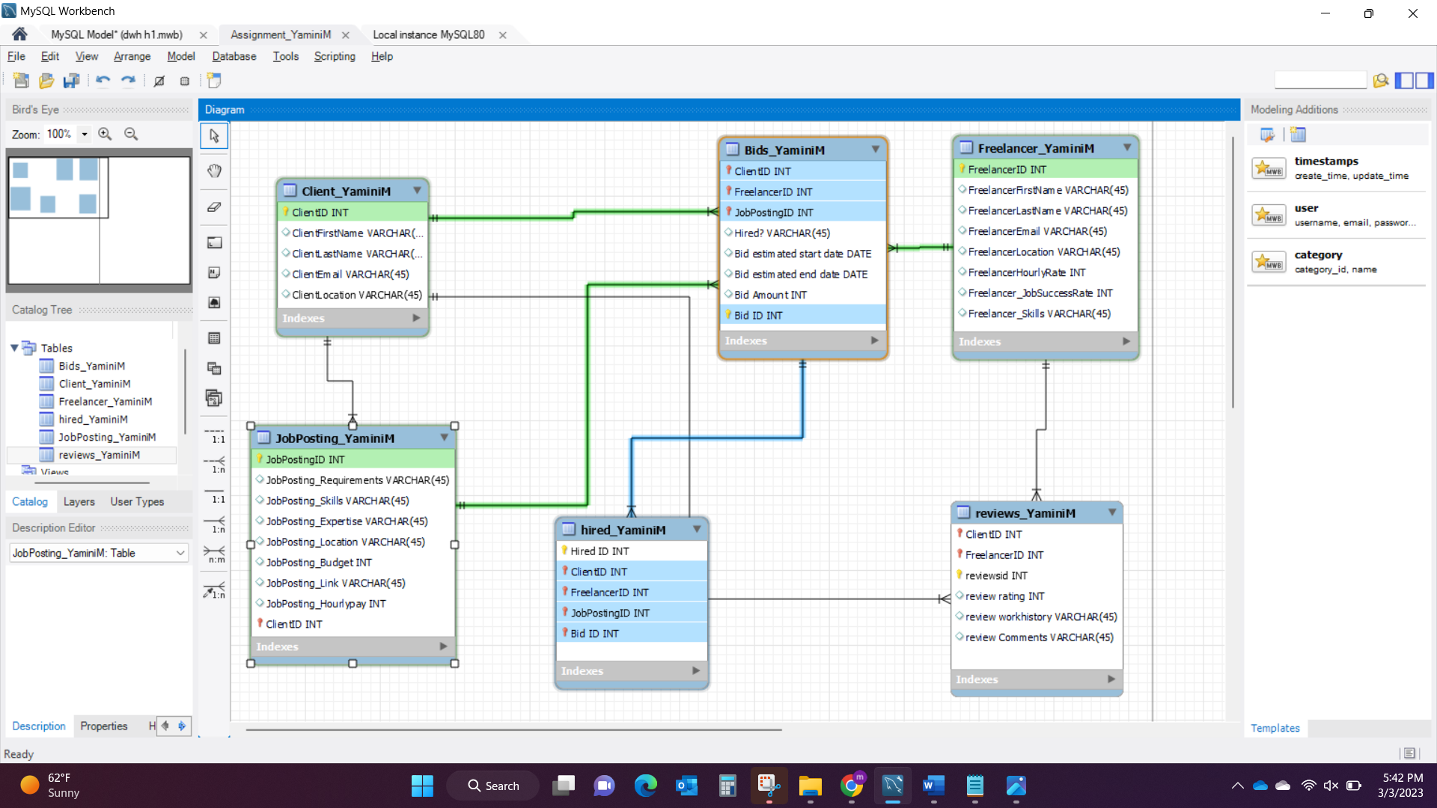

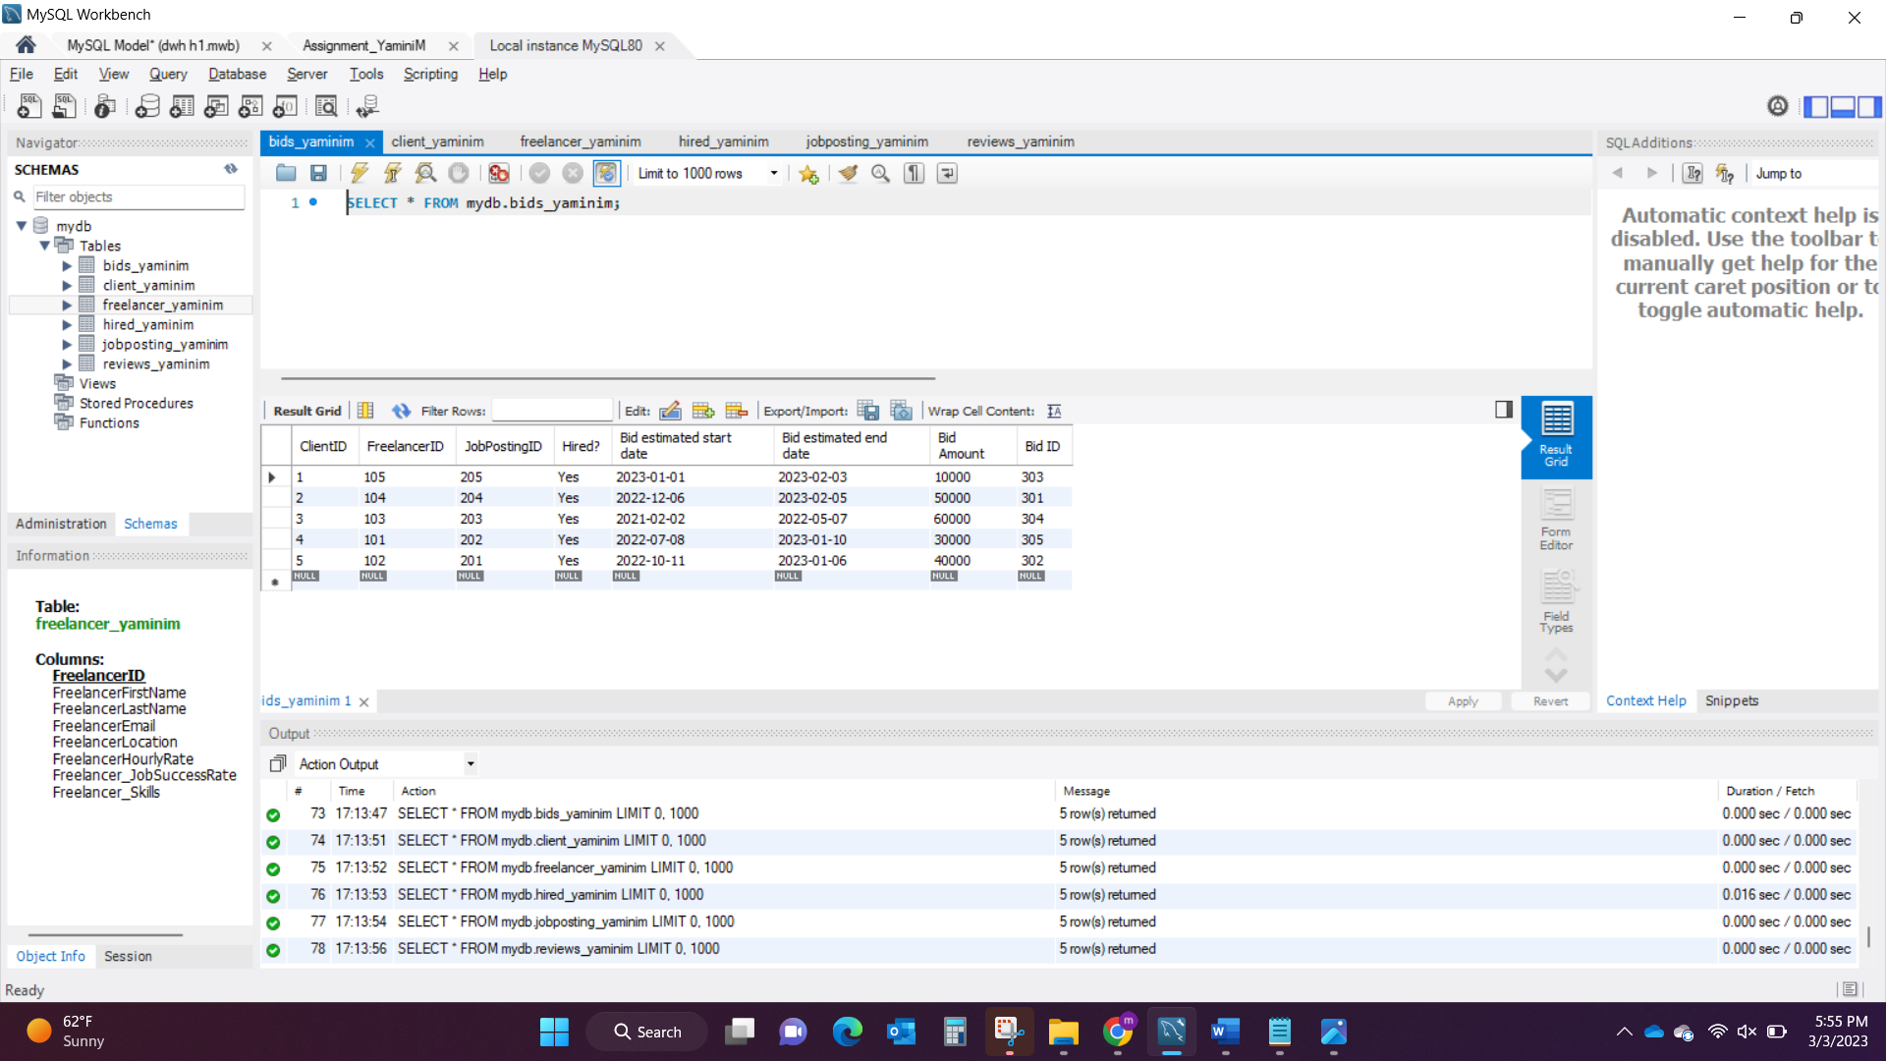

**Table 5:** hired_YaminiM table has 5 entities and 5 attributes, hired ID is the primary key. ClientID, FreelancerID, JobPostingID, BidID are the Foreign Keys. This table is associated with Bids_YaminiM table.

I have separated bids table and hired table to keep a track of all bids for each project.

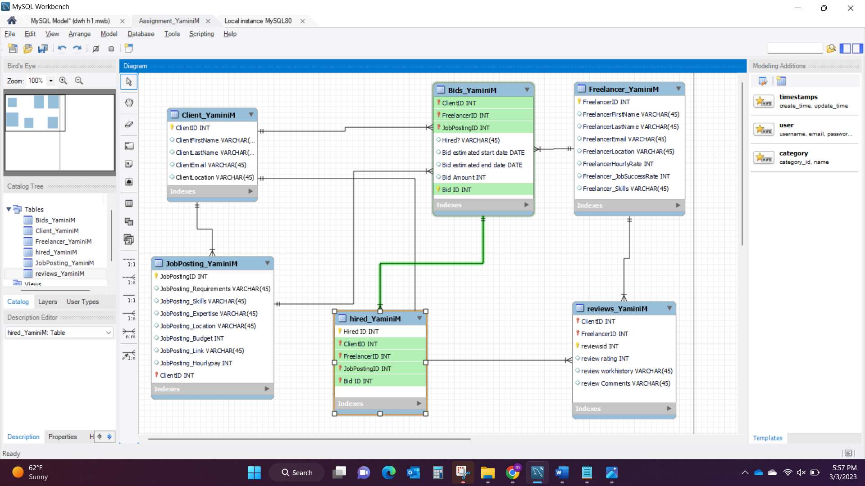

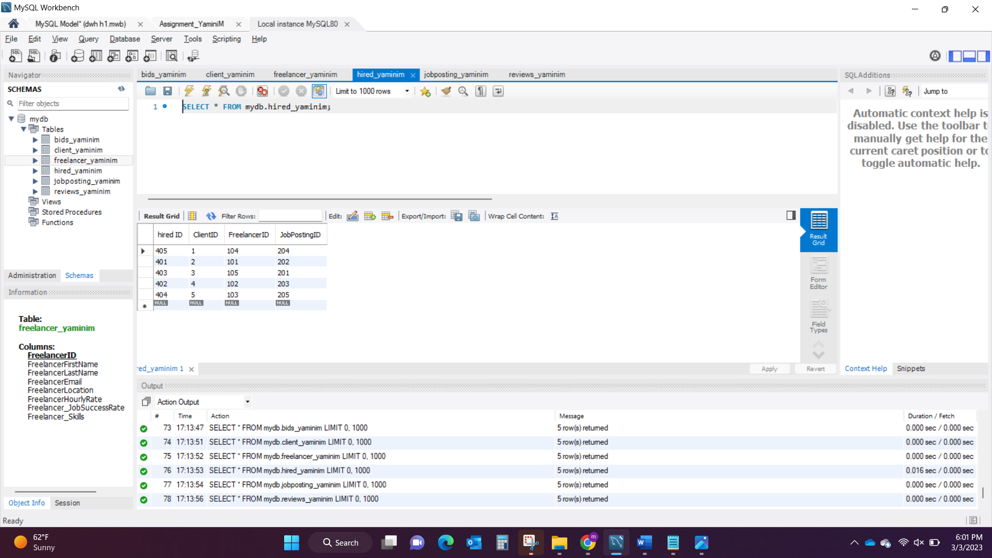

**Table 6:** reviews_YaminiM table has 6 entities and 5 attributes. reviewsID is primary key, ClientID and FreelancerID are the Foreign Keys.

Reviews_YaminiM table is associate table between Freelancer_YaminiM and Client_YaminiM table.

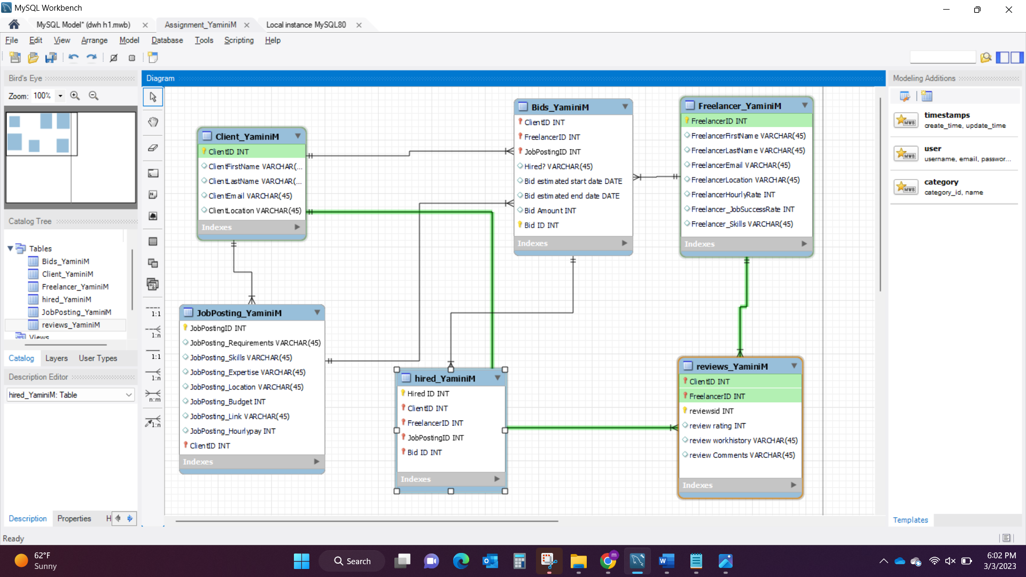

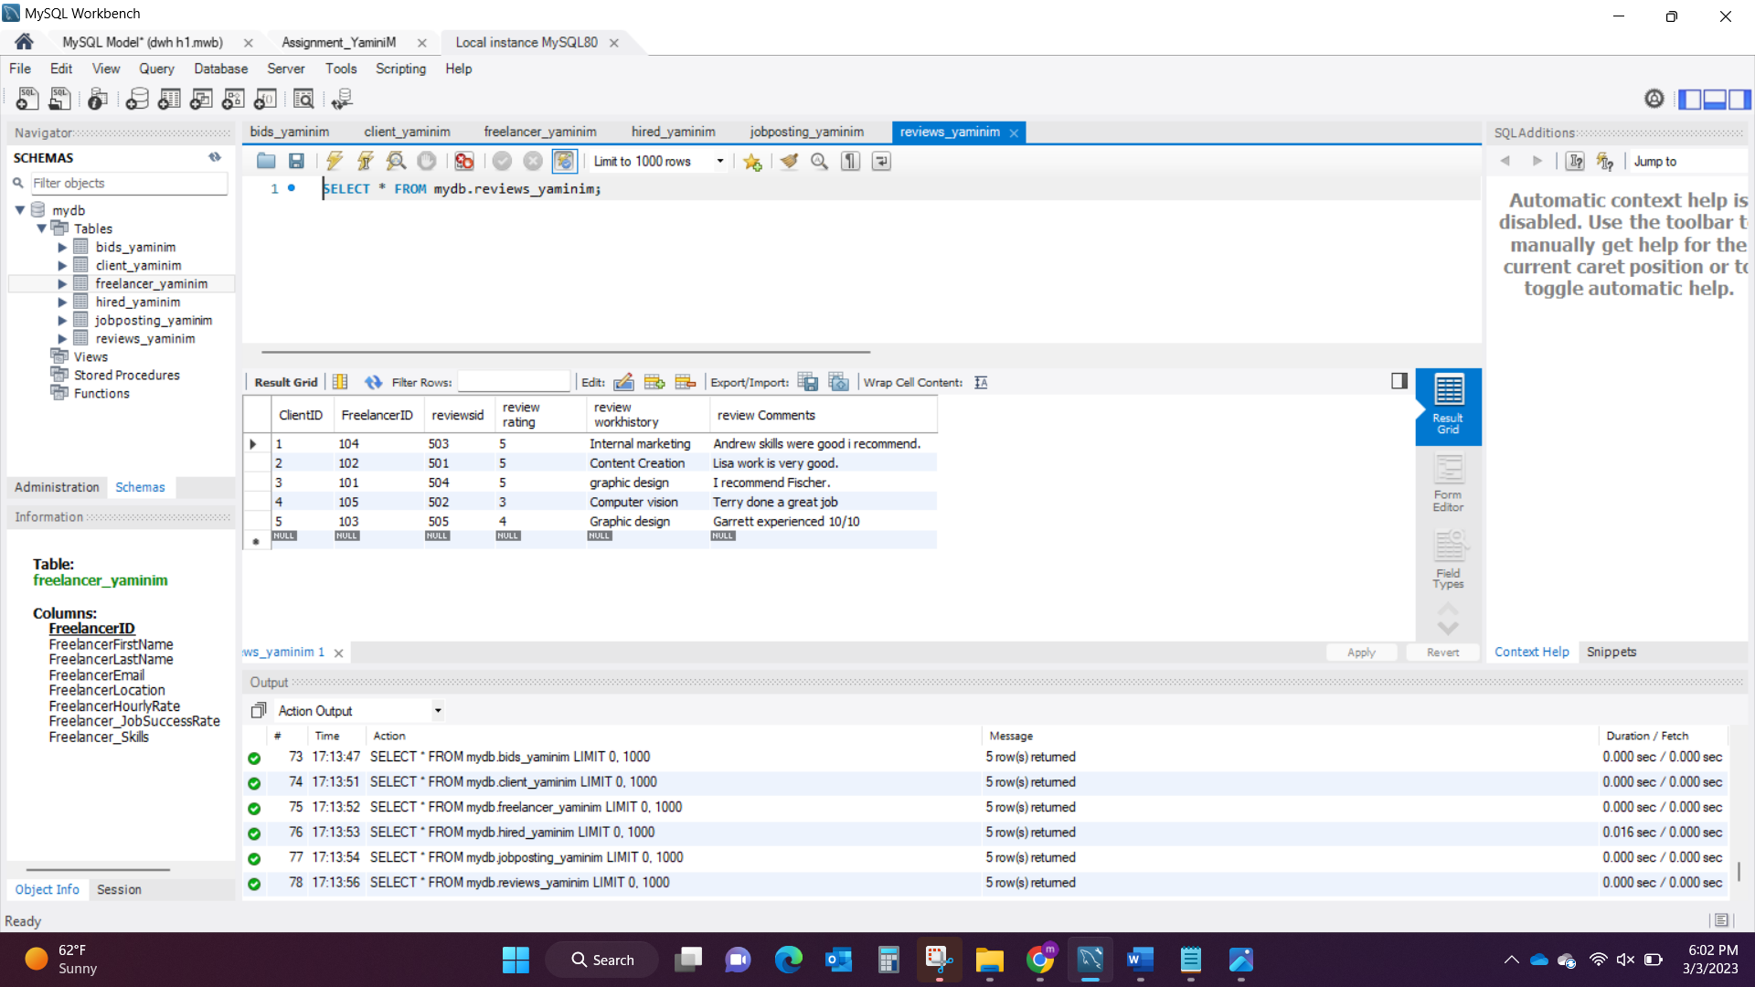

**Dimension Model for Upwork**

Dimension Model Snapshot:

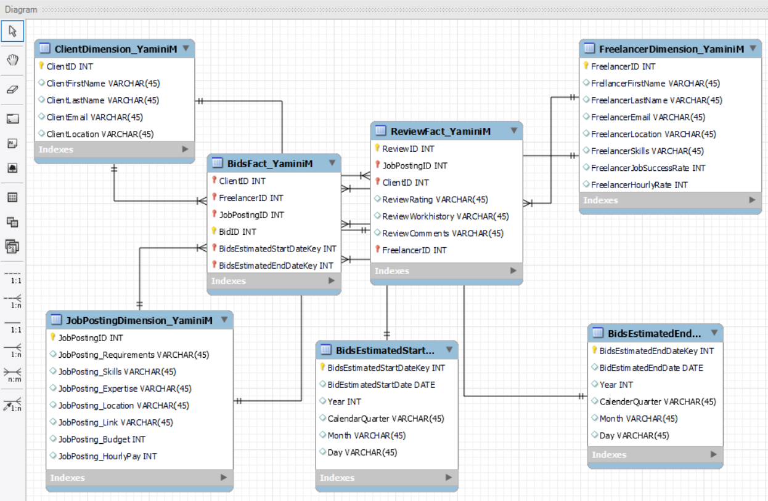

The Dimension Model Diagram above contains of 7 tables with 5 Dimension tables and 2 Fact tables:

1. ClientDimension_YaminiM
2. FreelancerDimension_YaminiM
3. JobPostingDimension_YaminiM
4. BidsEstimatedStartDateDimension_YaminiM
5. BidsEstimatedEndDateDimension_YaminiM
6. BidsFact_YaminiM
7. ReviewFact_YaminiM

**Table1:** ClientDimension_YaminiM – ClientID is the primary key and no foreign keys in this table. There are 5 Entities and 10 Attributes.

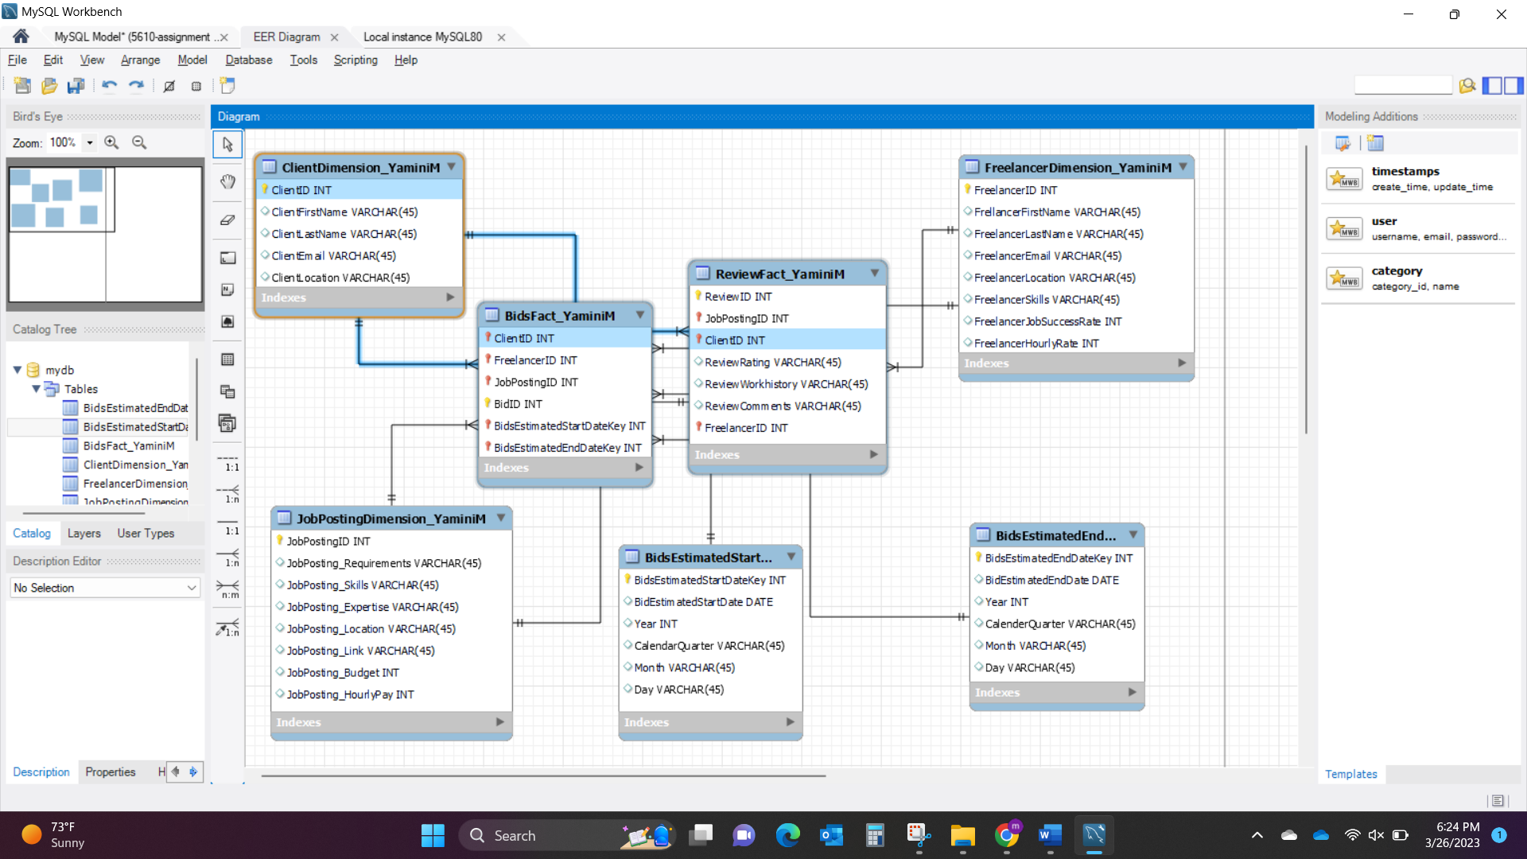

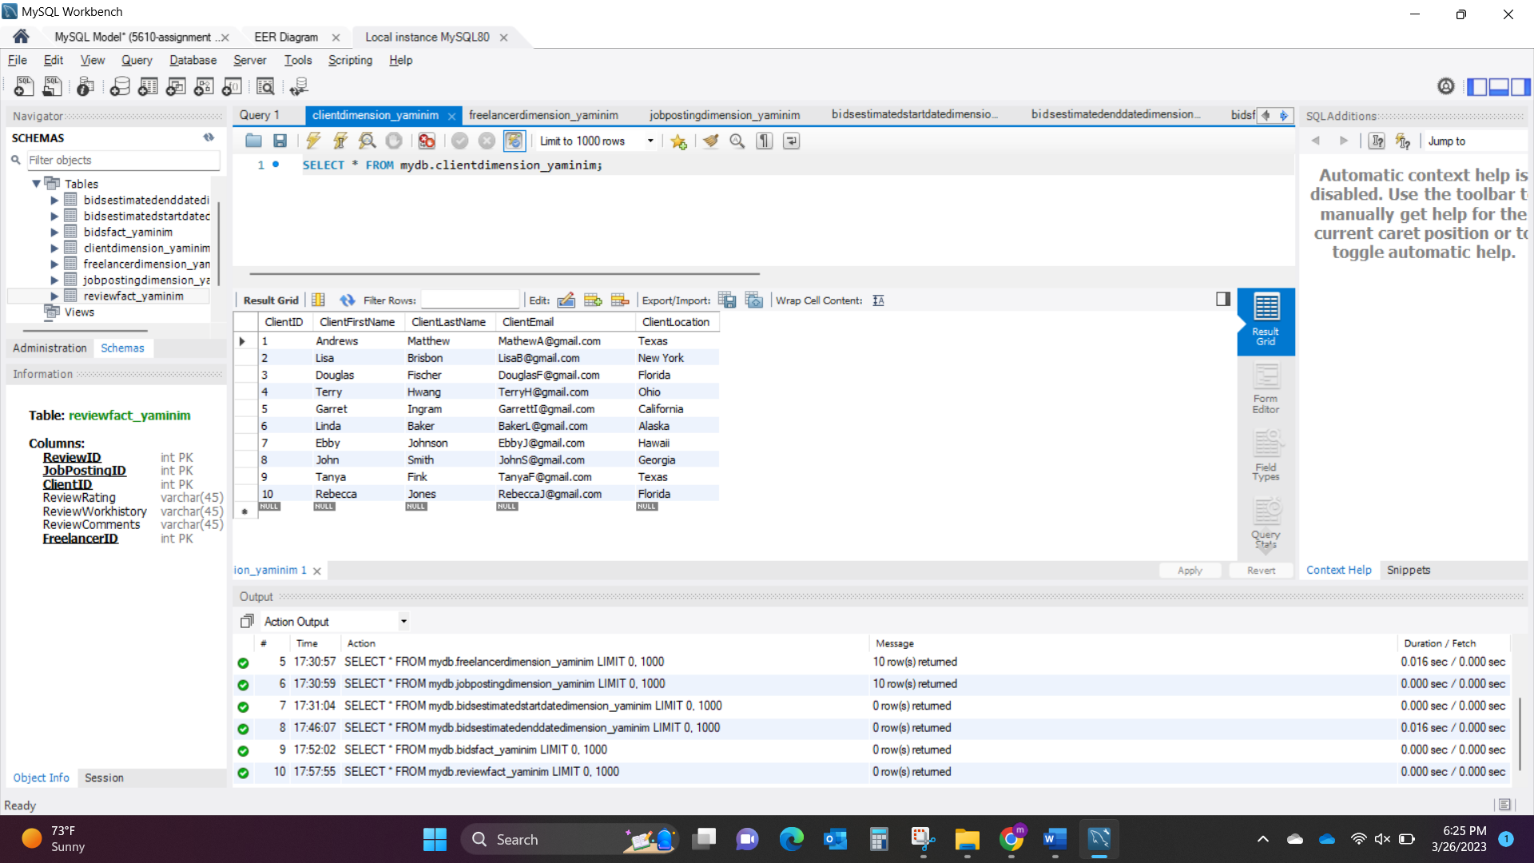

**Table2:** FreelancerDimension_YaminiM – FreelancerID is the primary key and no foreign keys in this table. There are 8 Entities and 10 Attributes.

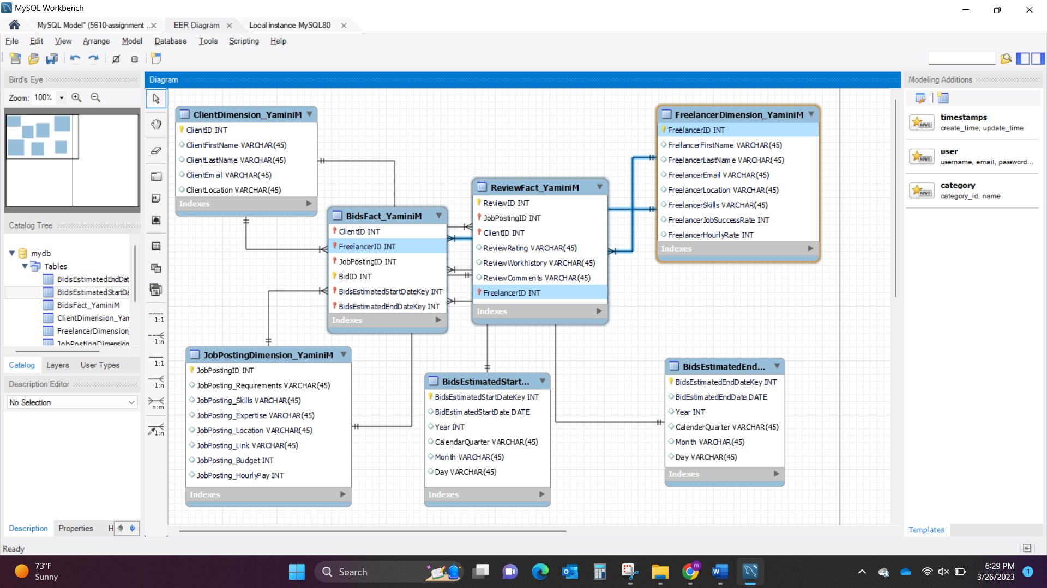

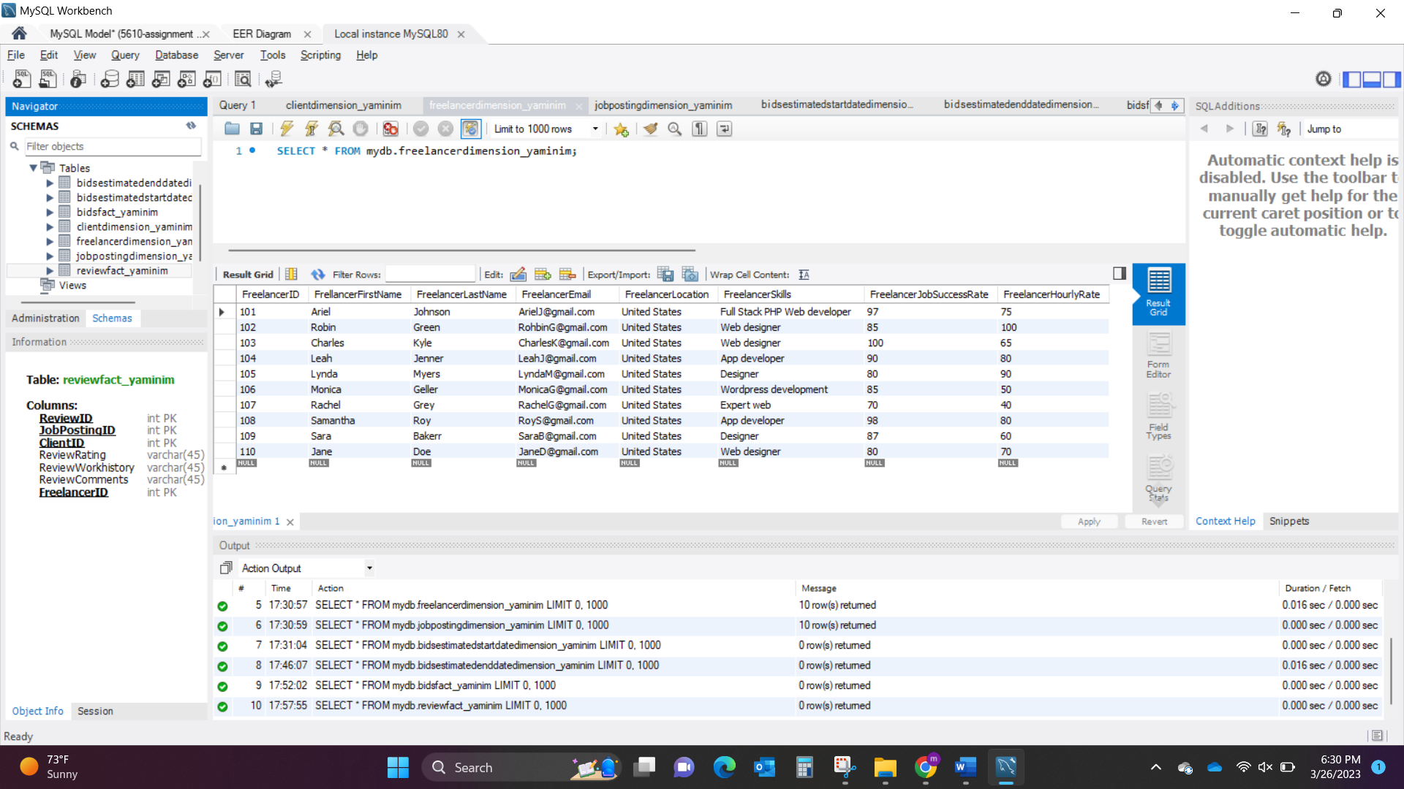

**Table3:** JobPostingDimension_YaminiM – JobPostingID is the primary key and no foreign keys in this table. There are 8 Entities and 10 Attributes.

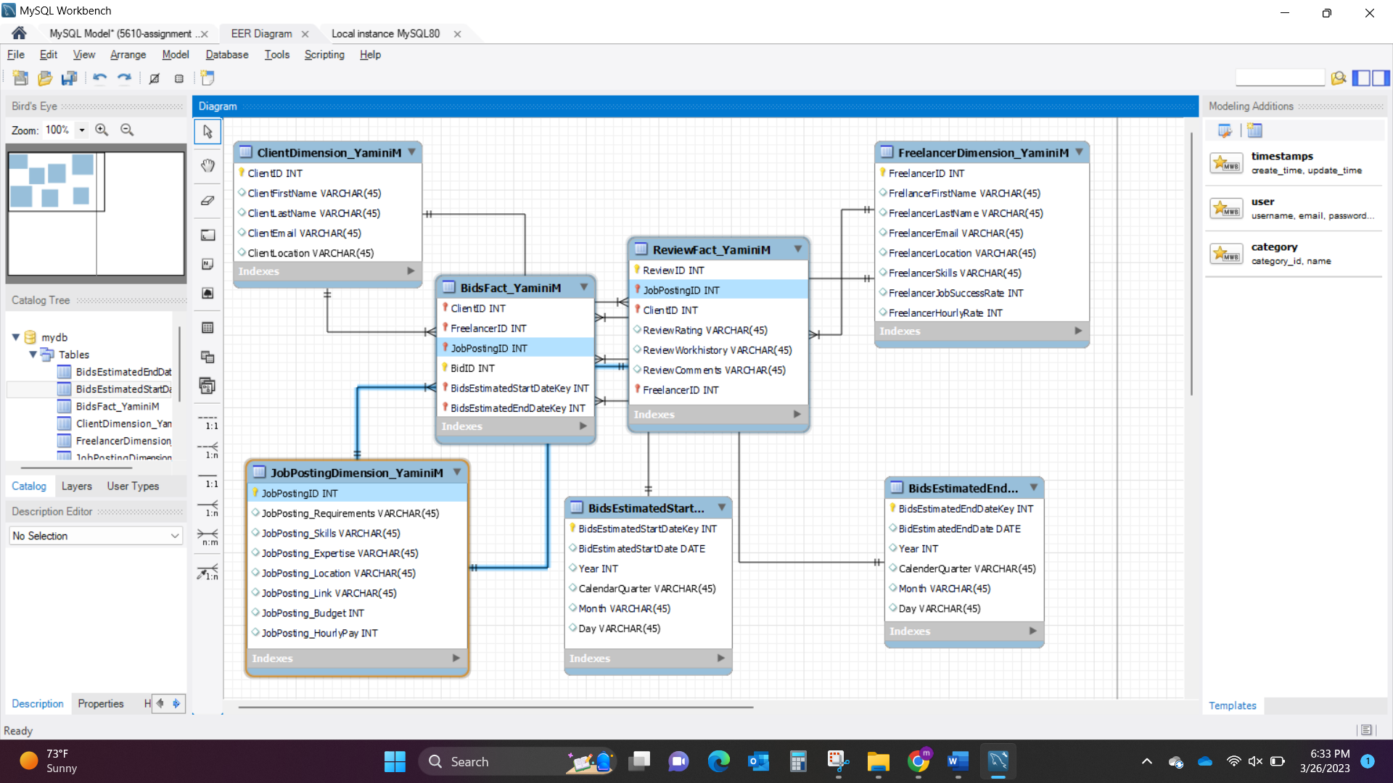

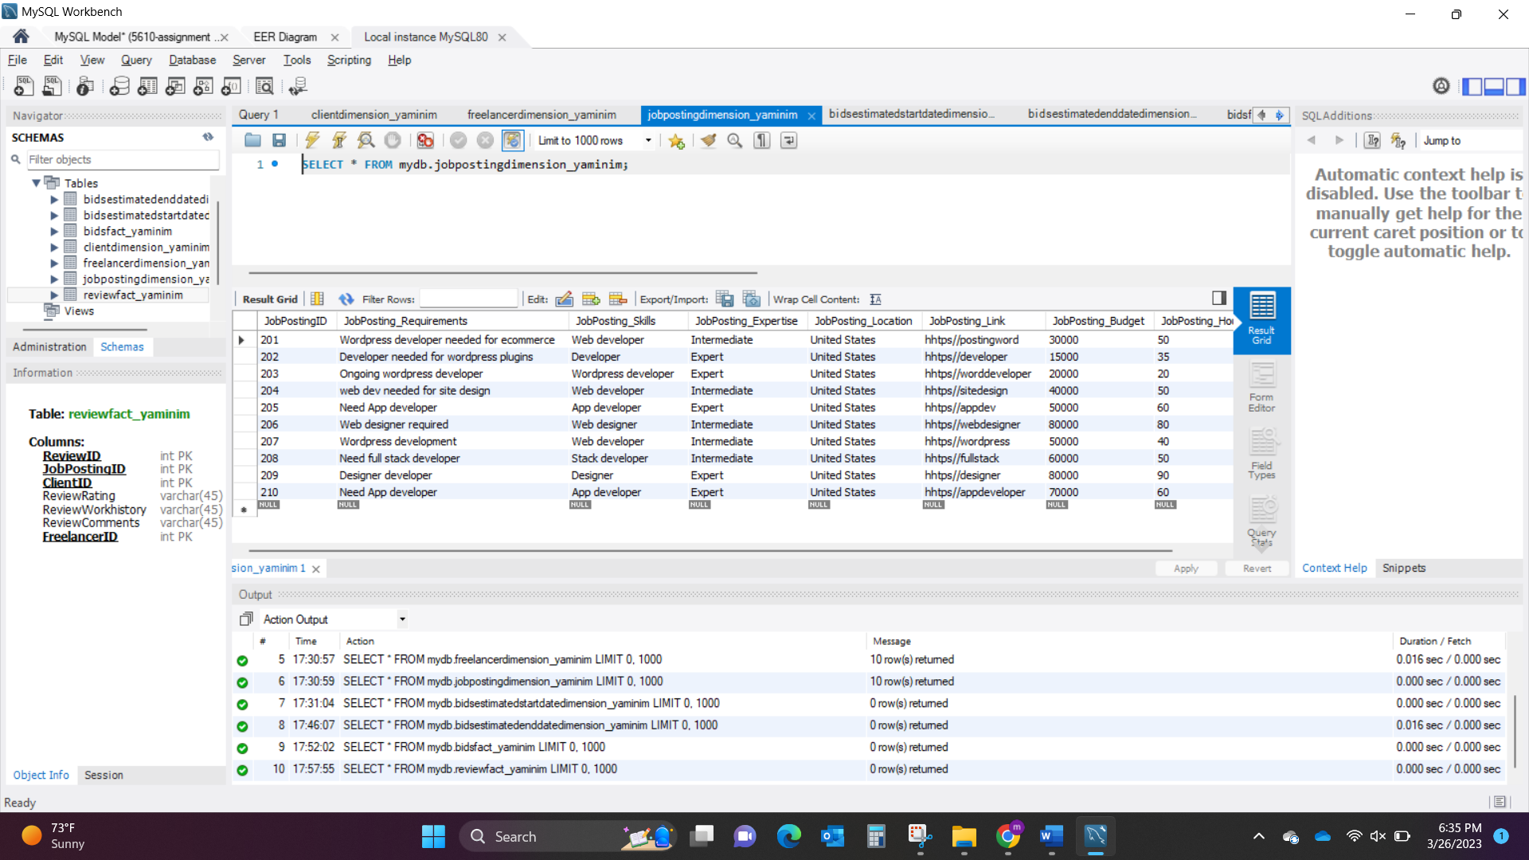

**Table4:** BidsEstimatedStartDateDimension_YaminiM – BidsEstimatedStartDatekey is the primary key and no foreign keys. There are 6 Entities and 10 Attributes.

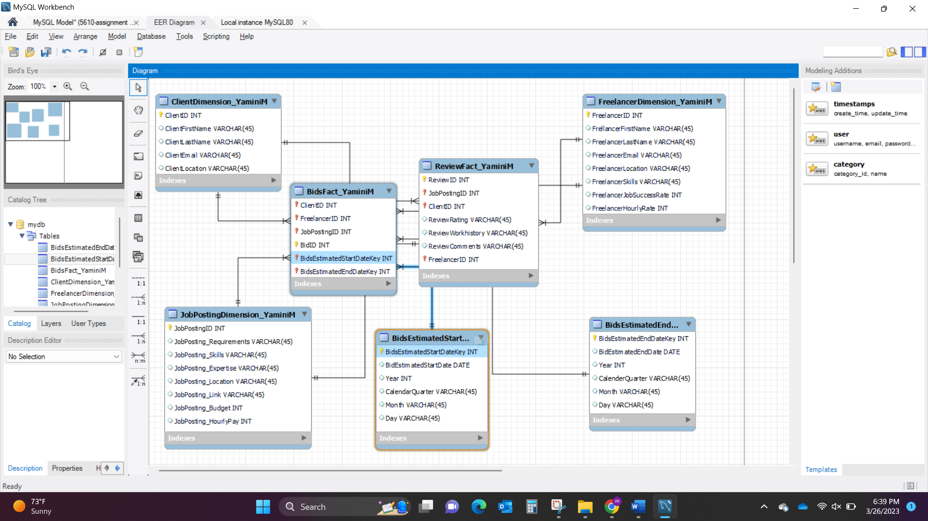

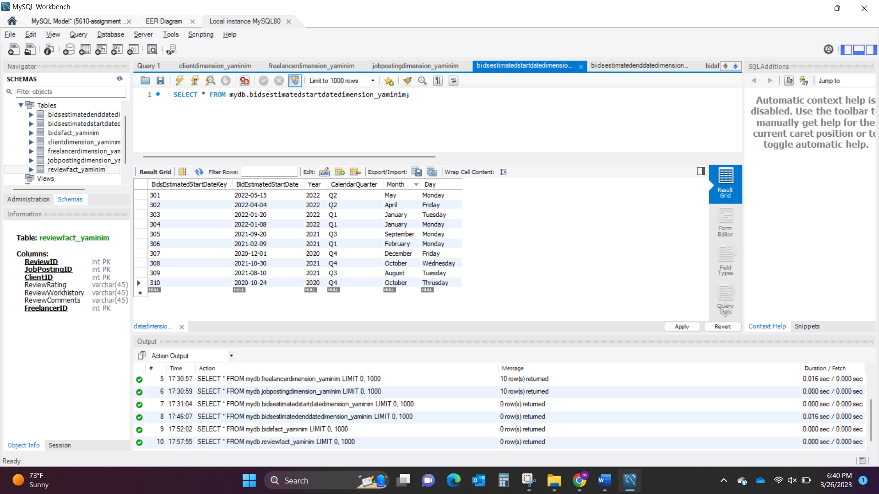

**Table5:** BidsEstimatedEndDateDimenion_YaminiM – BidsEstimatedEndDatekey is the primary key and no foreign keys. There are 6 Entities and 10 Attributes.

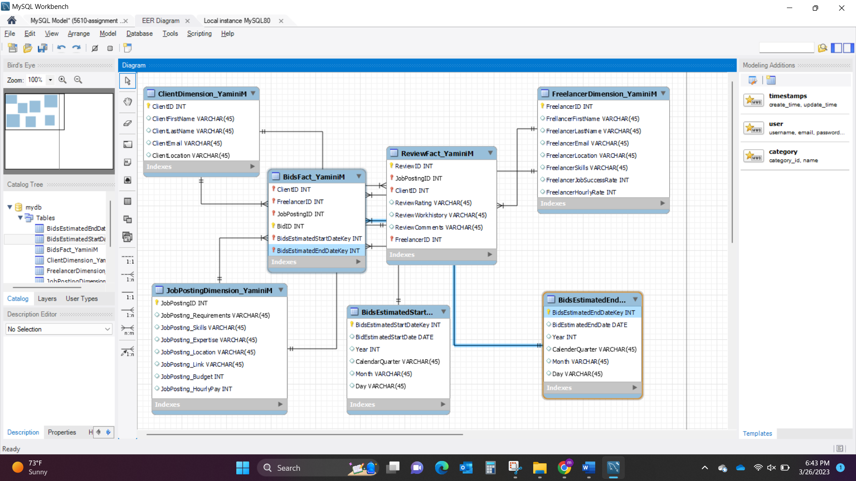

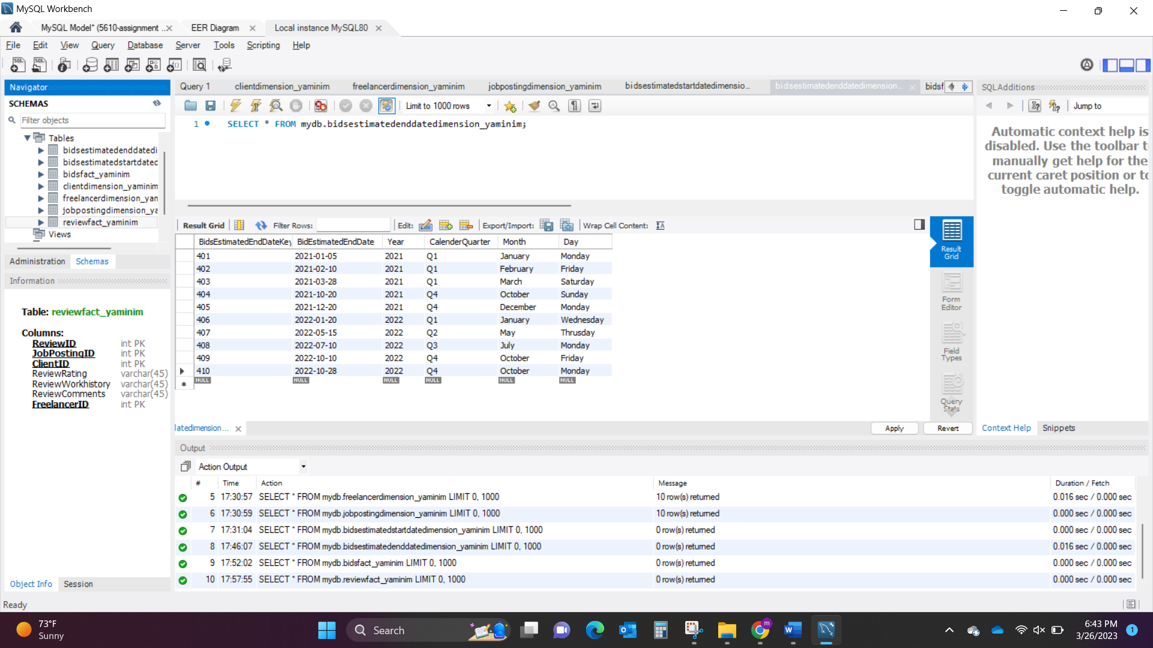

**Table6:** BidsFact_YaminiM – BidID is the primary key and ClientID, FreelancerID, JobPostingID, BidsEstimatedStartDatekey, BidsEstimatedEndDatekey are foreign keys in this table. There are 6 Entities and 10 attributes.

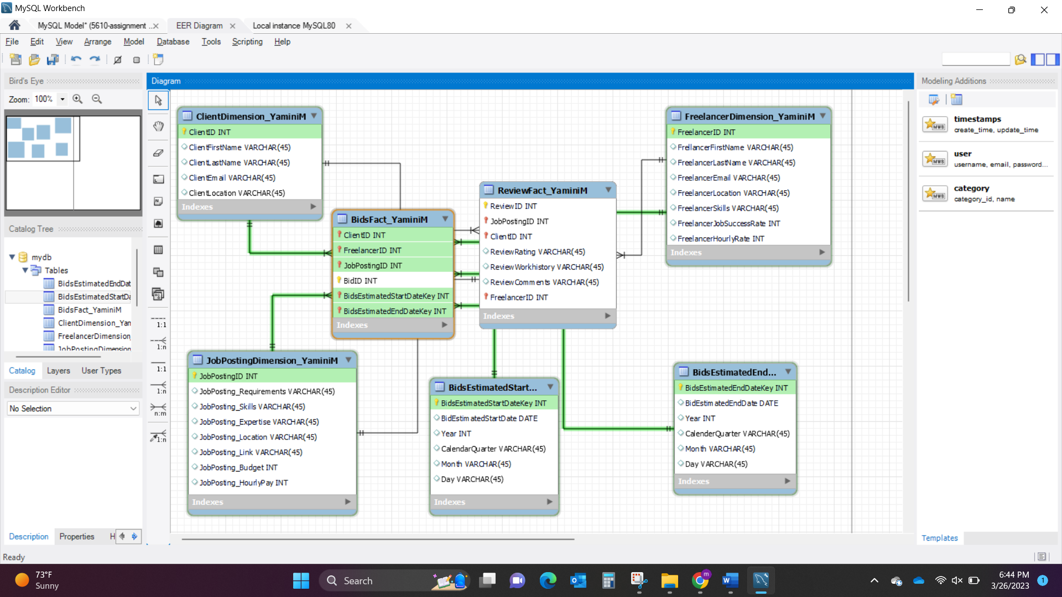

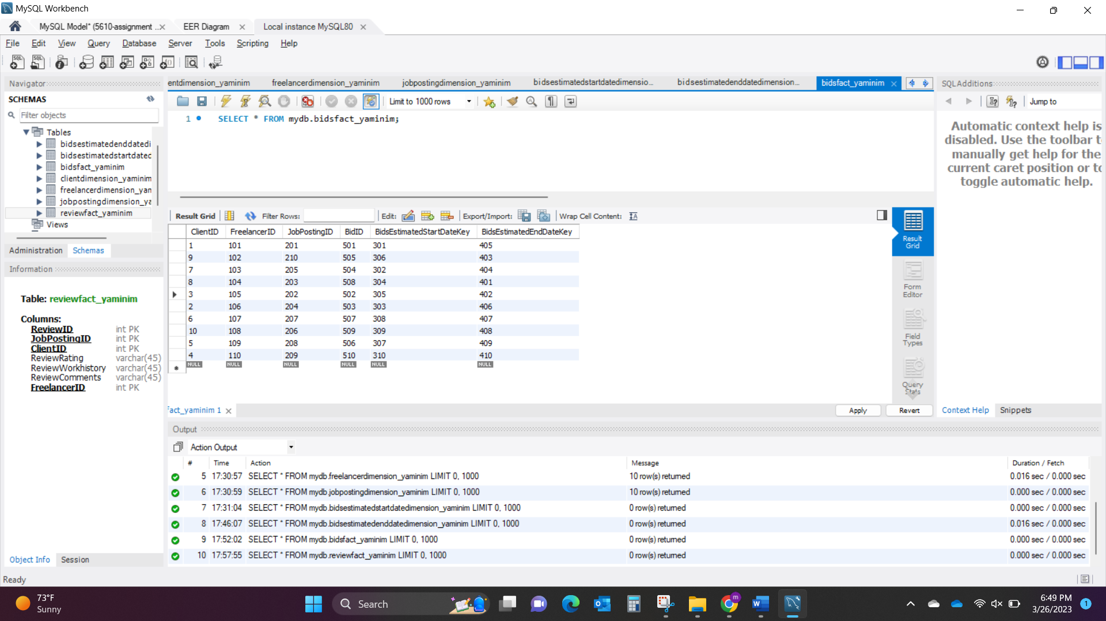

**Table7:** ReviewFact_YaminiM – ReviewID is the primary key and JobPostingID, ClientID, FreelancerID are the foreign keys. There are 7 Entities and 10 Attributes.

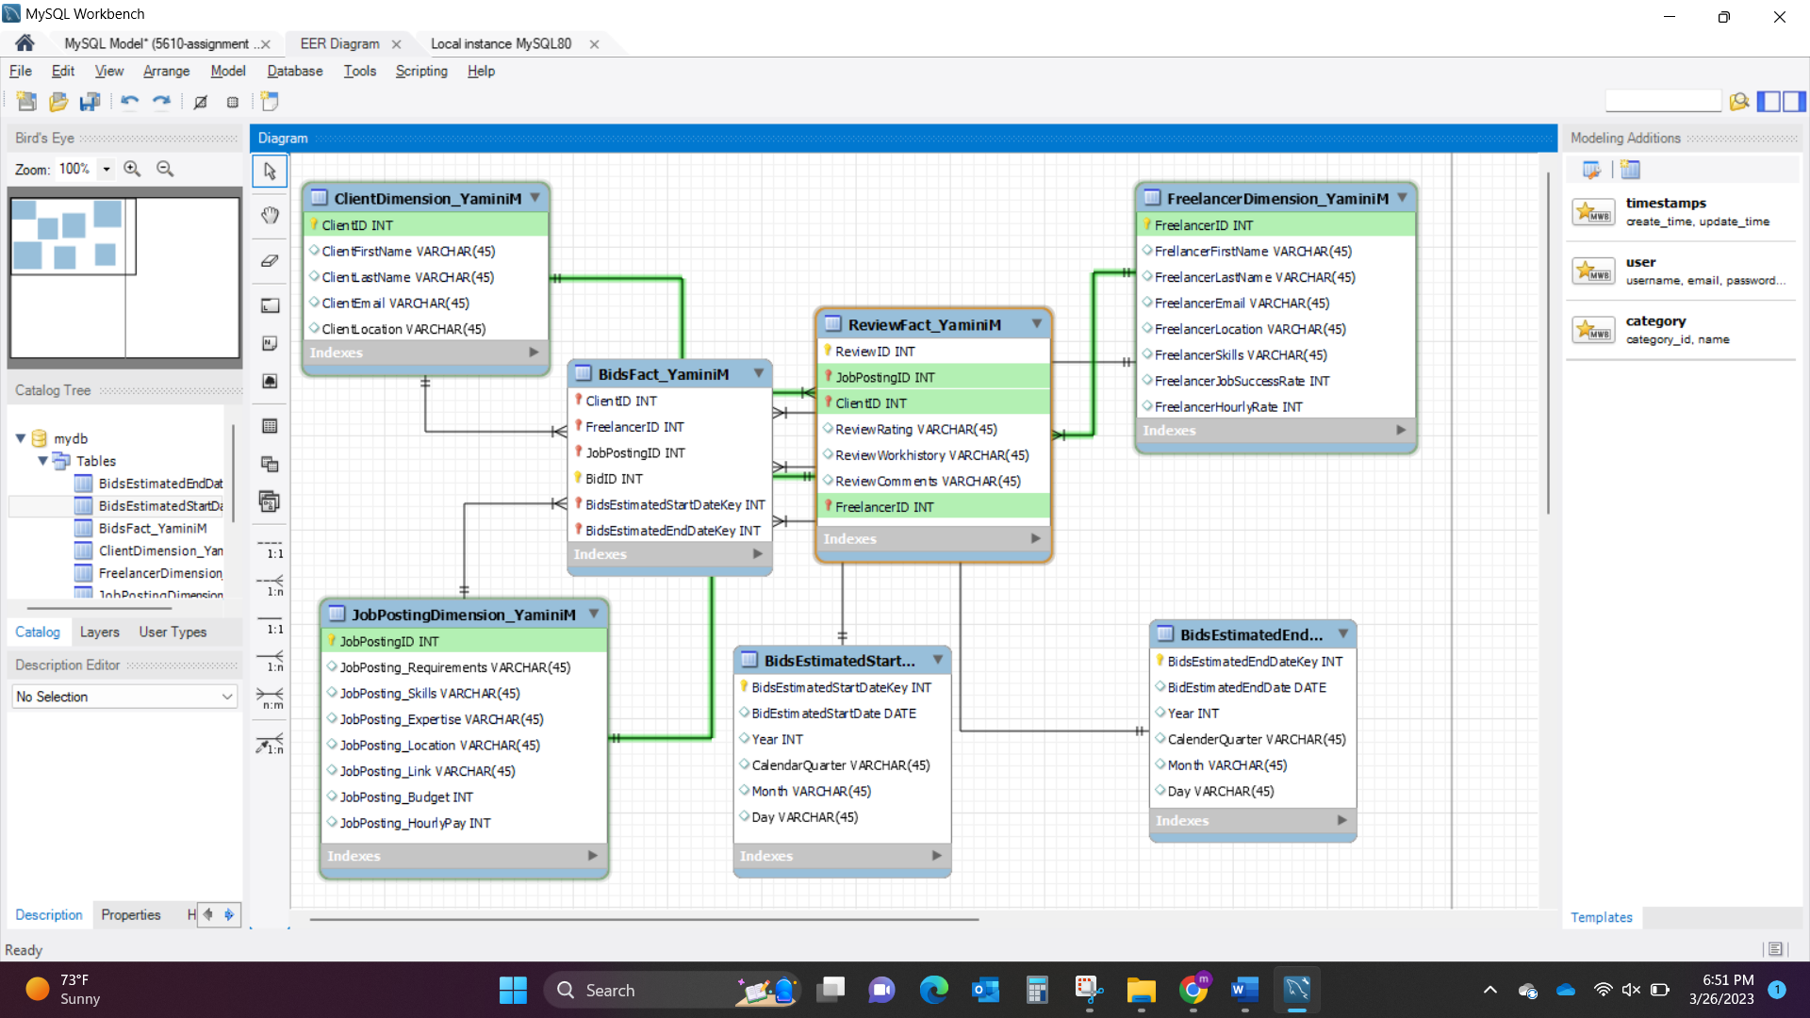

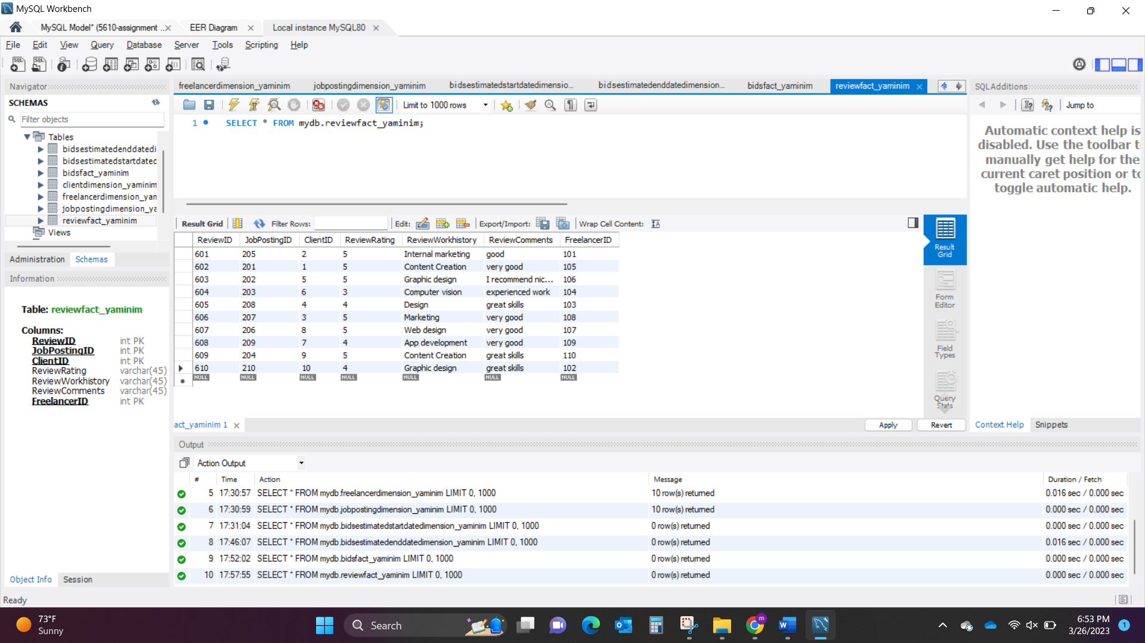

**Data Visualization using QlikView for Dimension Model**

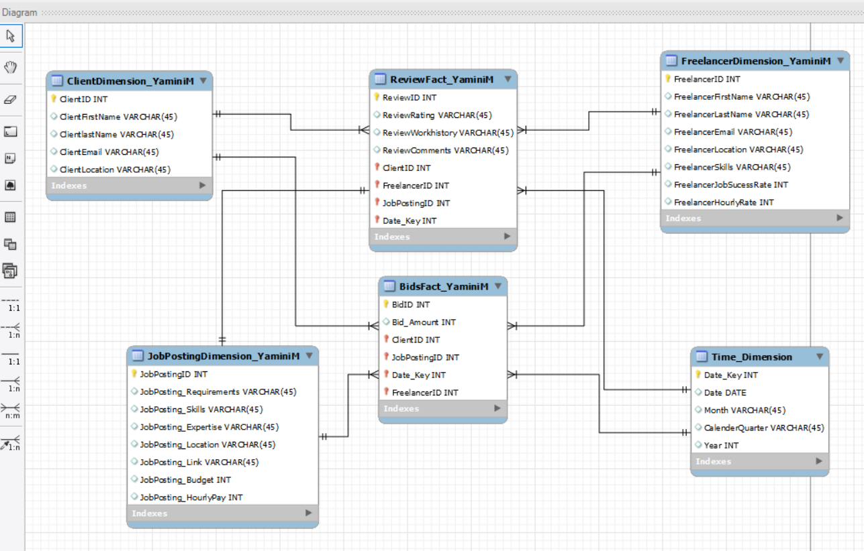

I have created QlikView application on top if Dimension Model database from Assignment 2.

**As Per Discussion:**

As per the Business need the Time dimension can be created, in my above model I have created one Time Dimension table where the Date_Key is the primary key and connected to review and bids fact tables as Date_key. I concatenated Bids and Review table.

Or it can also be created as Time Dimension connected to Review fact table and named as Review date key and for Bids Fact table as Start date key and End Date key. With this in QlikView Time Dimension will Alias 3 times as review, start, end date table and the main Time Dimension table will be hanging.

**Back End Data Model:**

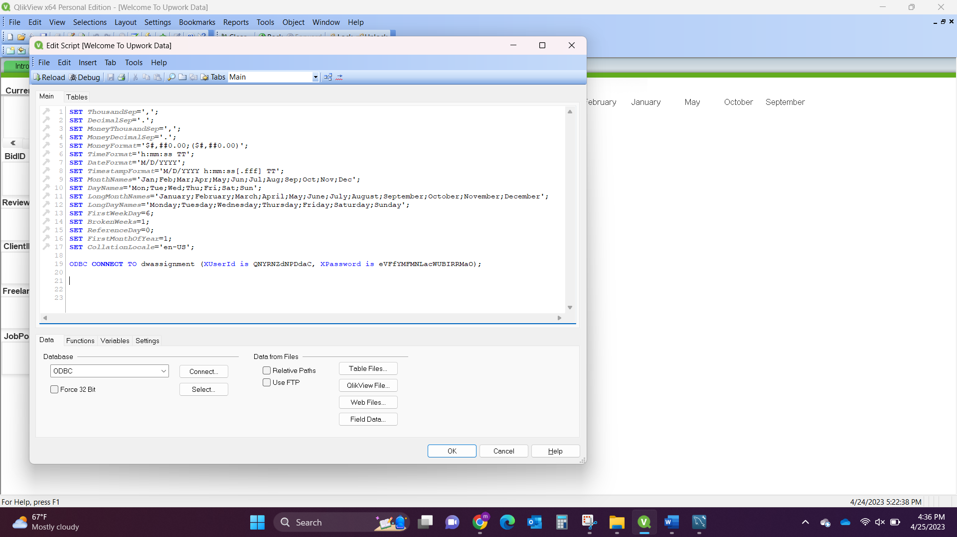

/****************Client Table*******************/  
Client:  
**LOAD** ClientID,  
 ClientFirstName,  
 ClientlastName,  
 ClientEmail,  
 ClientLocation;  
**SQL** SELECT *  
FROM mydb.`clientdimension_yaminim`;  
  
/****************Freelancer Table*******************/  
Freelancer:  
**LOAD** FreelancerID,  
 FreelancerFirstName,  
 FreelancerLastName,  
 FreelancerEmail,  
 FreelancerLocation,  
 FreelancerSkills,  
 FreelancerJobSucessRate,  
 FreelancerHourlyRate;  
**SQL** SELECT *  
FROM mydb.`freelancerdimension_yaminim`;  
  
/****************Job Posting Table*******************/  
JobPosting:  
**LOAD** JobPostingID,  
 `JobPosting_Requirements`,  
 `JobPosting_Skills`,  
 `JobPosting_Expertise`,  
 `JobPosting_Location`,  
 `JobPosting_Link`,  
 `JobPosting_Budget`,  
 `JobPosting_HourlyPay`;  
**SQL** SELECT *  
FROM mydb.`jobpostingdimension_yaminim`;  
  
/****************Time Dimension Table*******************/  
TimeDimension:  
**LOAD** `Date_Key`,  
 Date,  
 Month,  
 CalenderQuarter,  
 Year;  
**SQL** SELECT *  
FROM mydb.`time_dimension`;  
  
/****************Bids Fact Table*******************/  
BidsFact:  
**LOAD** BidID,  
 `Bid_Amount`,  
 ClientID,  
 JobPostingID,  
 `Date_Key`,  
 FreelancerID;  
**SQL** SELECT *  
FROM mydb.`bidsfact_yaminim`;  
  
Concatenate  
  
/****************Review Fact Table*******************/  
ReviewFact:  
**LOAD** ReviewID,  
 ReviewRating,  
 ReviewWorkhistory,  
 ReviewComments,  
 ClientID,  
 FreelancerID,  
 JobPostingID,  
 `Date_Key`;  
**SQL** SELECT *  
FROM mydb.`reviewfact_yaminim`;

I have added concatenate between review fact table and bids fact table to combine the tables from synthetic table and keys.

**Table Structure:**

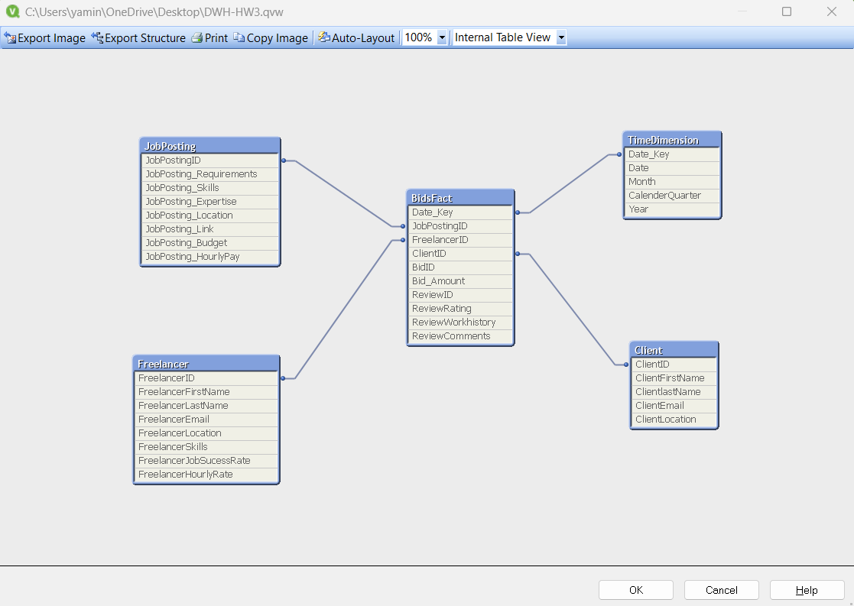

The data is populated with 10 records from Assignment 2.

**Front End Data Model:**

1. Introduction
2. Bid Amount by Location & Job Postings
3. Freelancer Ratings
4. Job Postings by Year
5. Job Posting Details

**Introduction-** This tab is an intro tab for Upwork data and added a search bar which takes to next sheet.

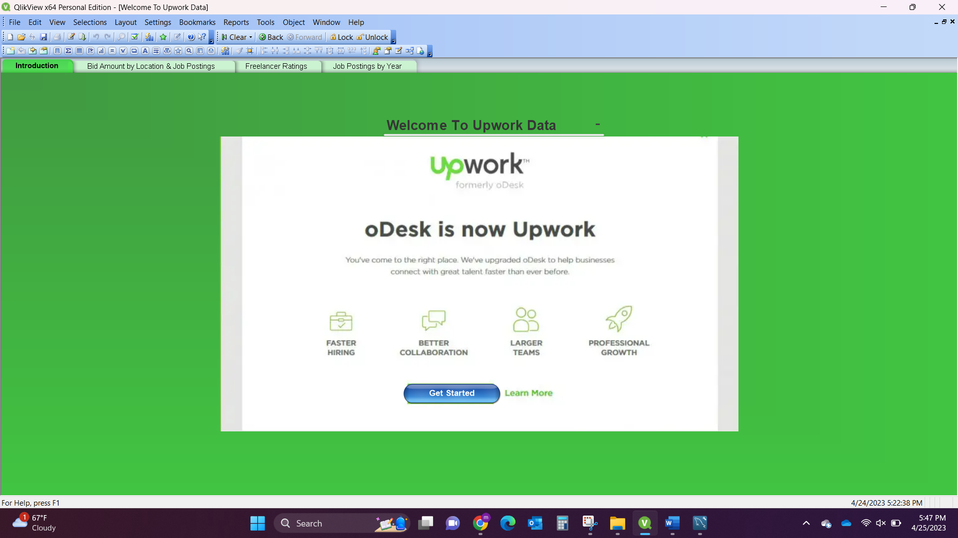

**Bid Amount by Location & Job Posting** Charts show the Amount by location which is higher and lower.

Another chart shows the bis amount per job posting.

In this sheet I have added current selections with backward, forward, and clear selections button, with the list boxes. Also added a search bar on the top with Year, Quarter, Month selections.

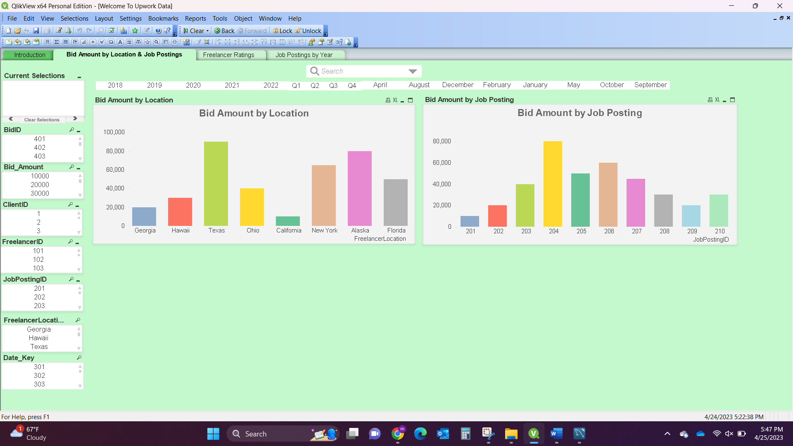

**Freelancer Ratings-** This sheet shows the Sum of Review Ratings of the freelancers.

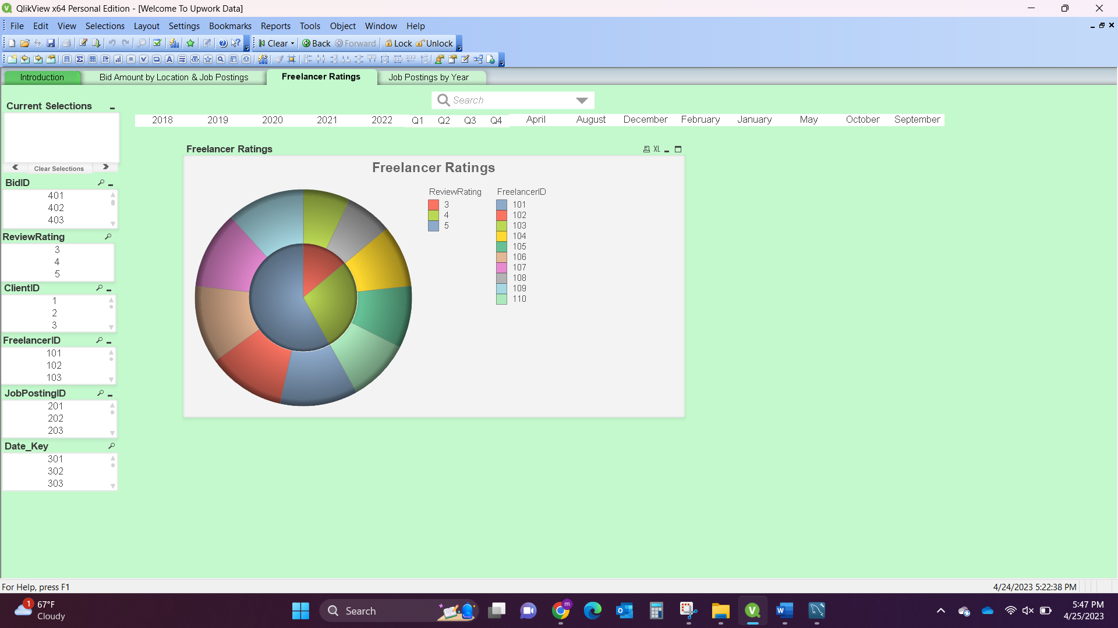

The below chart shows freelancers with review rating of 3.

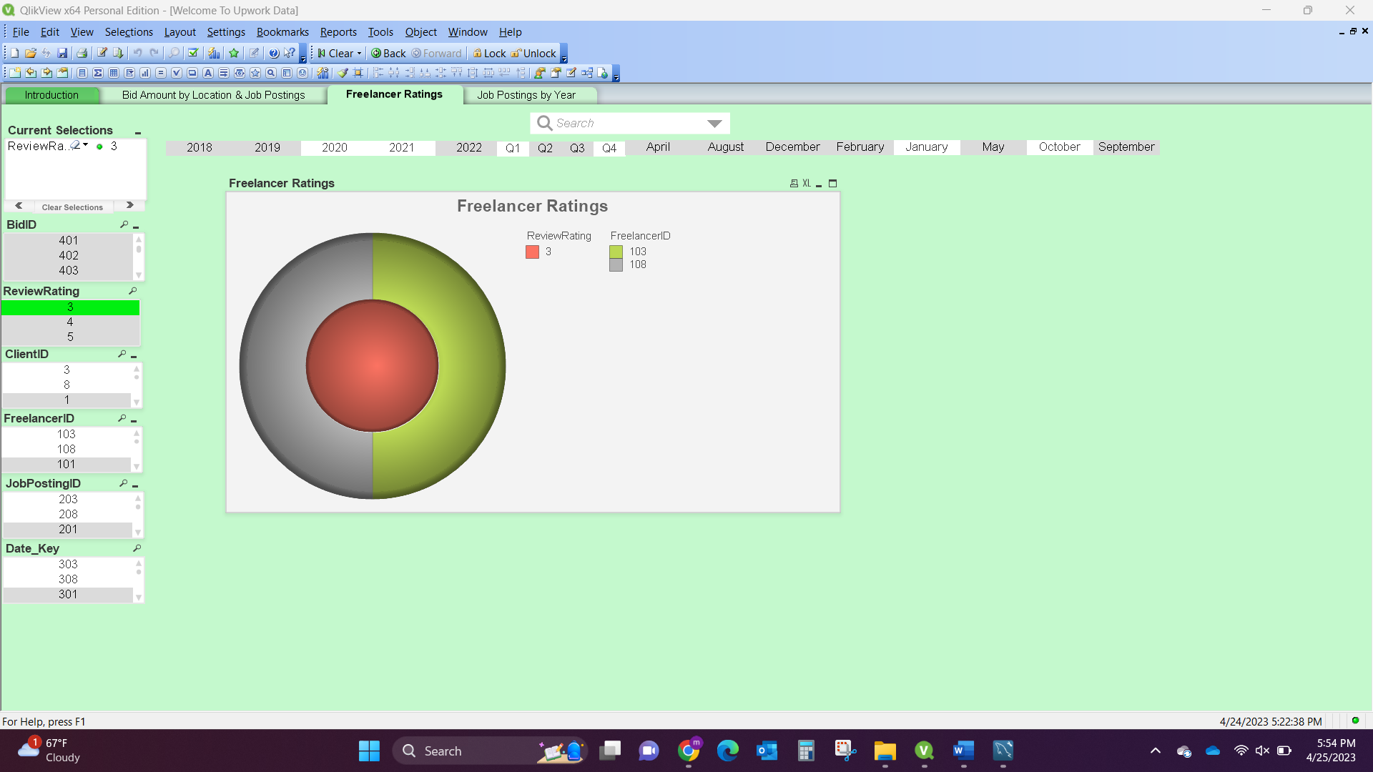

The below chart shows freelancers with a review rating of 4.

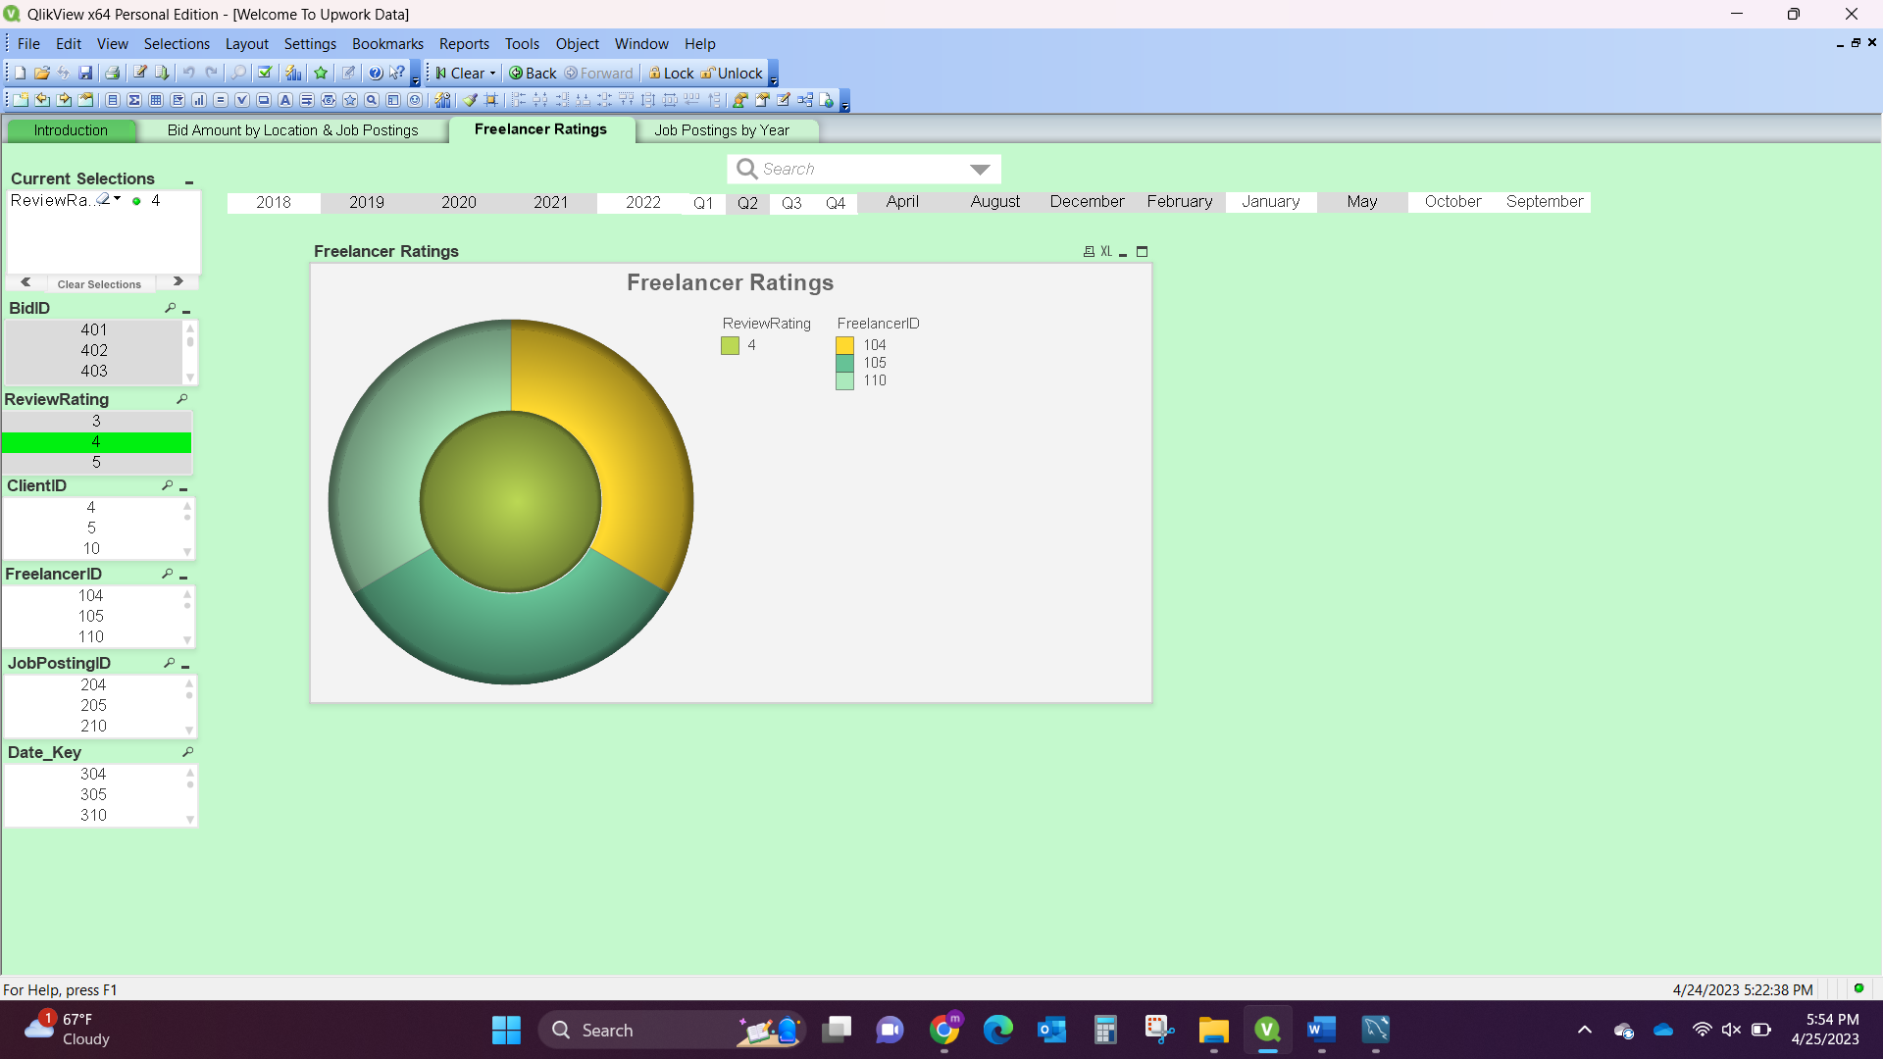

The below chart shows freelancers with a review rating of 5.

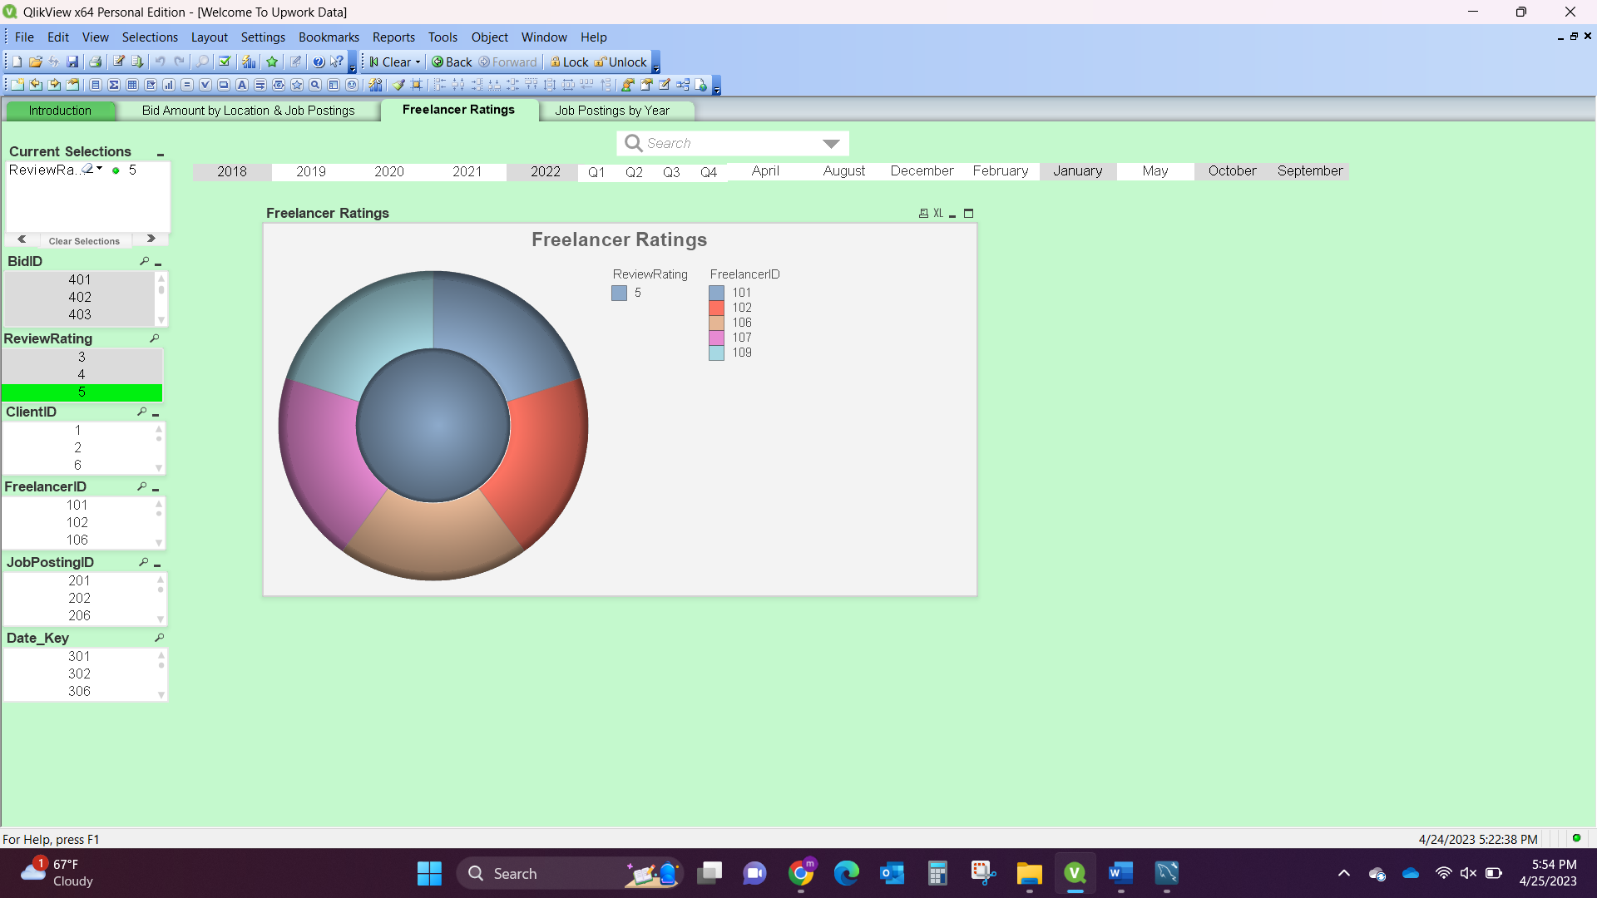

**Job Posting by Year-** This chart shows the total count of job postings by year.

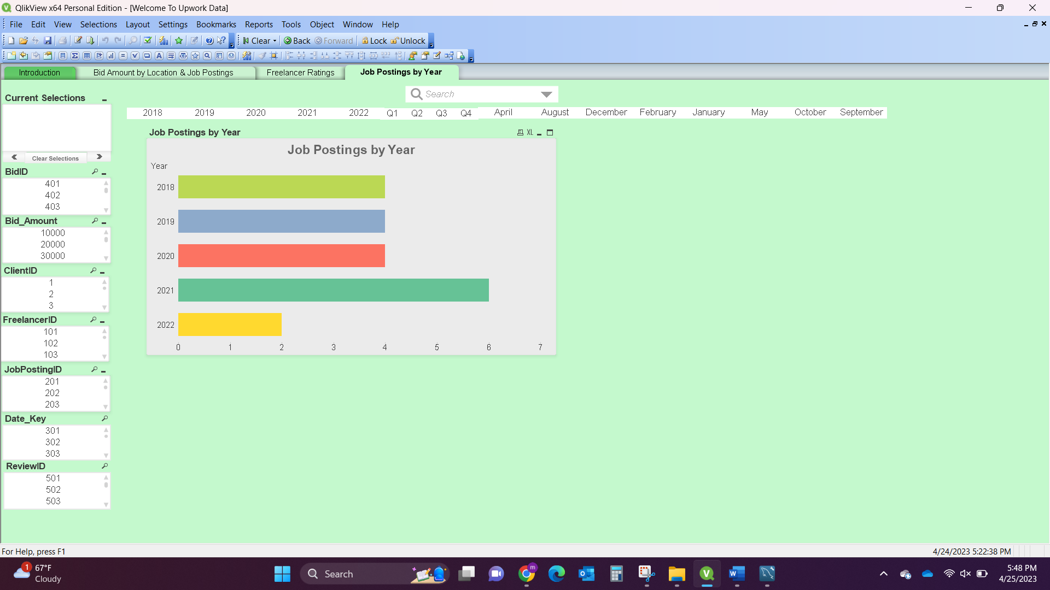

**Job Posting Details-** Details of Job postings from client requirements, budget, and bids to the posted job.

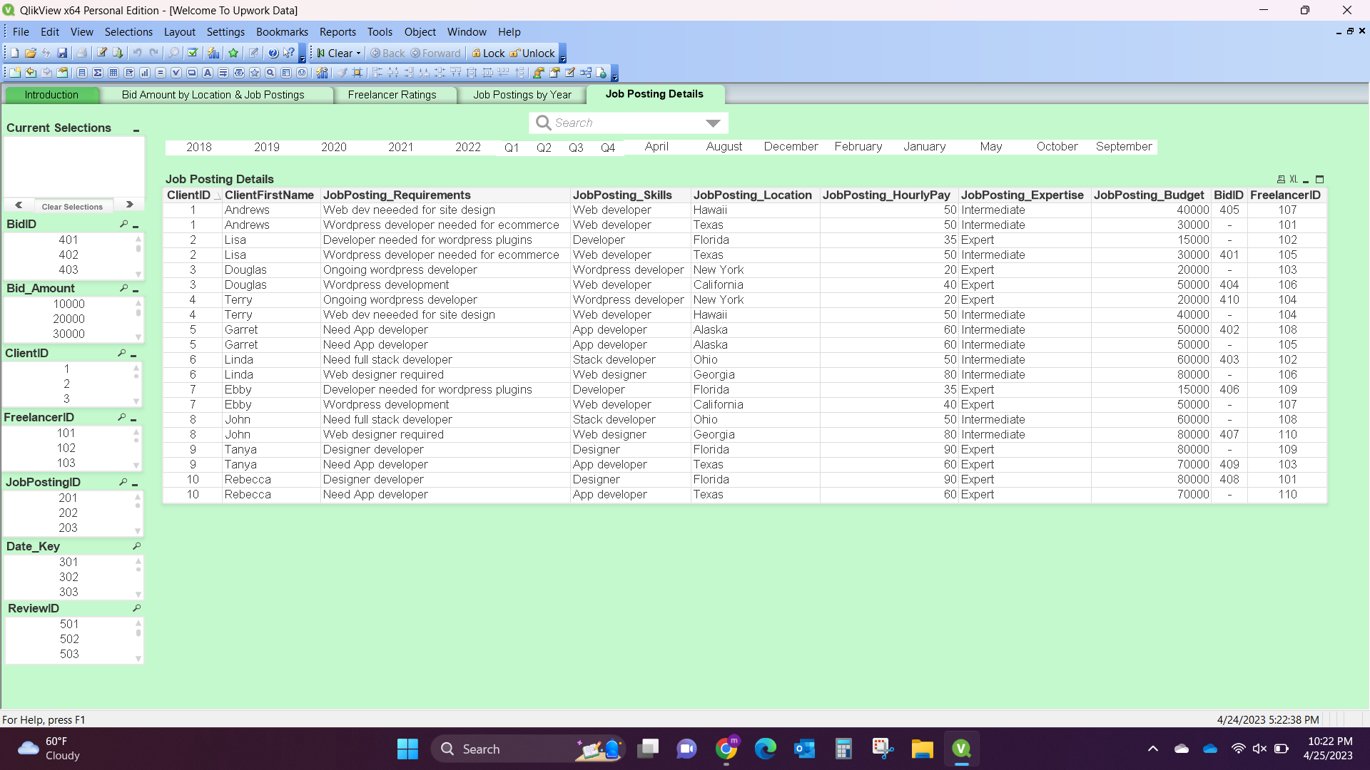

**Tableau Visualization**

* Data used in this assignment is Dimension Model.
* Resolved loops by making all the Dimension tables into one table by using Union function and connected bidsfact & reviewfact table.

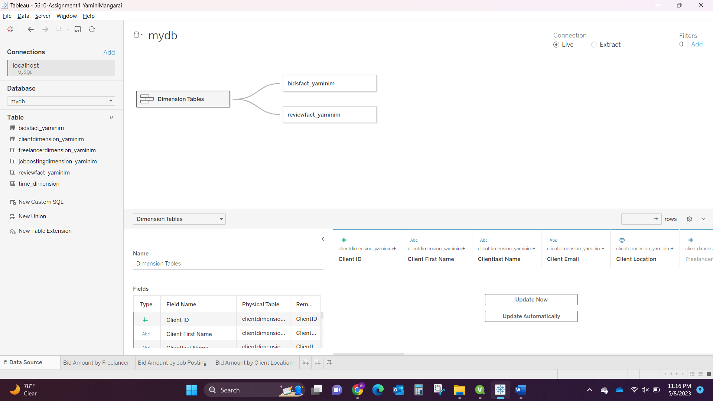

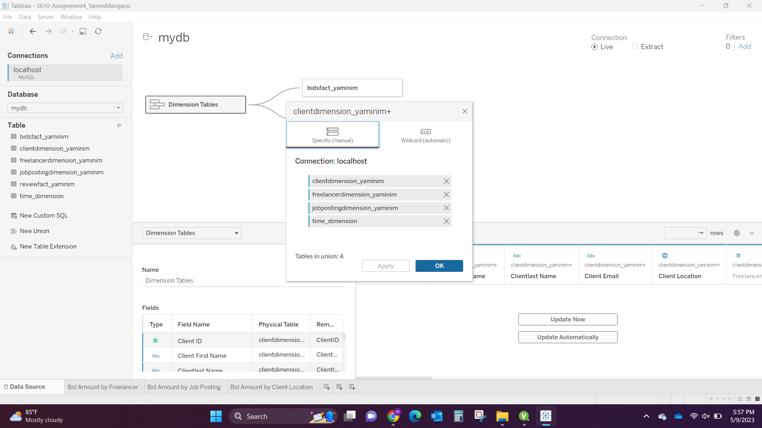

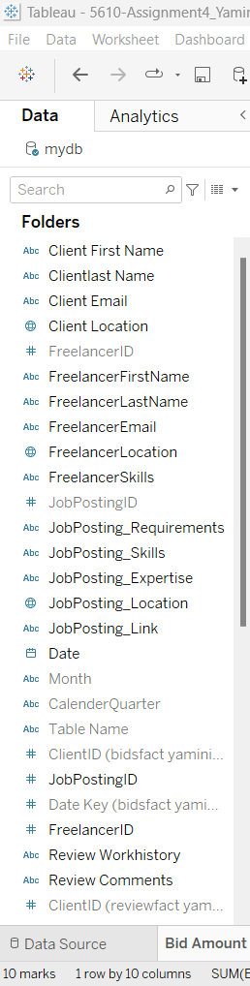 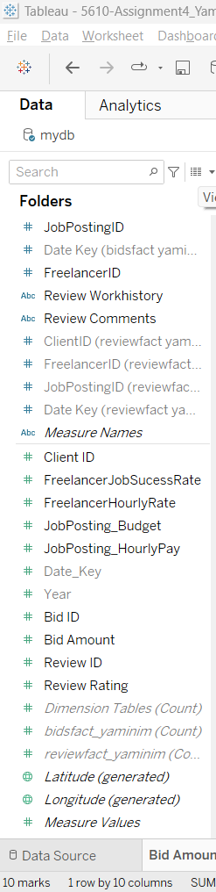

**Created 3 Visualizations:**

1. Bid Amount by Freelancer: Results of this visualization were correct as Freelancer ID 107 has the bid amount of 80K same as QlikView result.

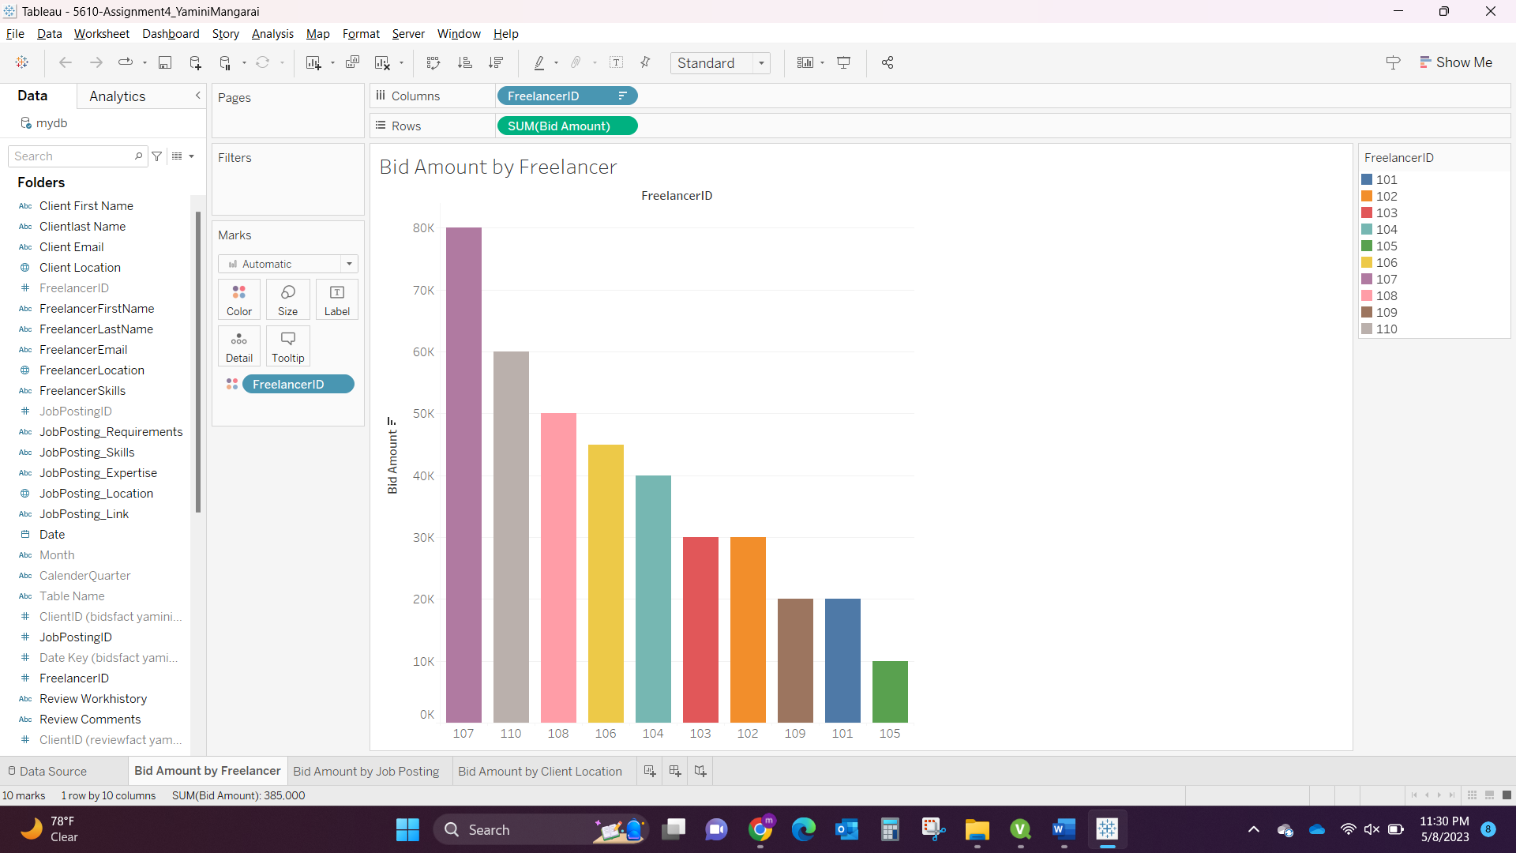

1. Bid Amount by Job Posting: The result of the bid amount of job postings is correct where Job posting 204 have bid amount 80K.

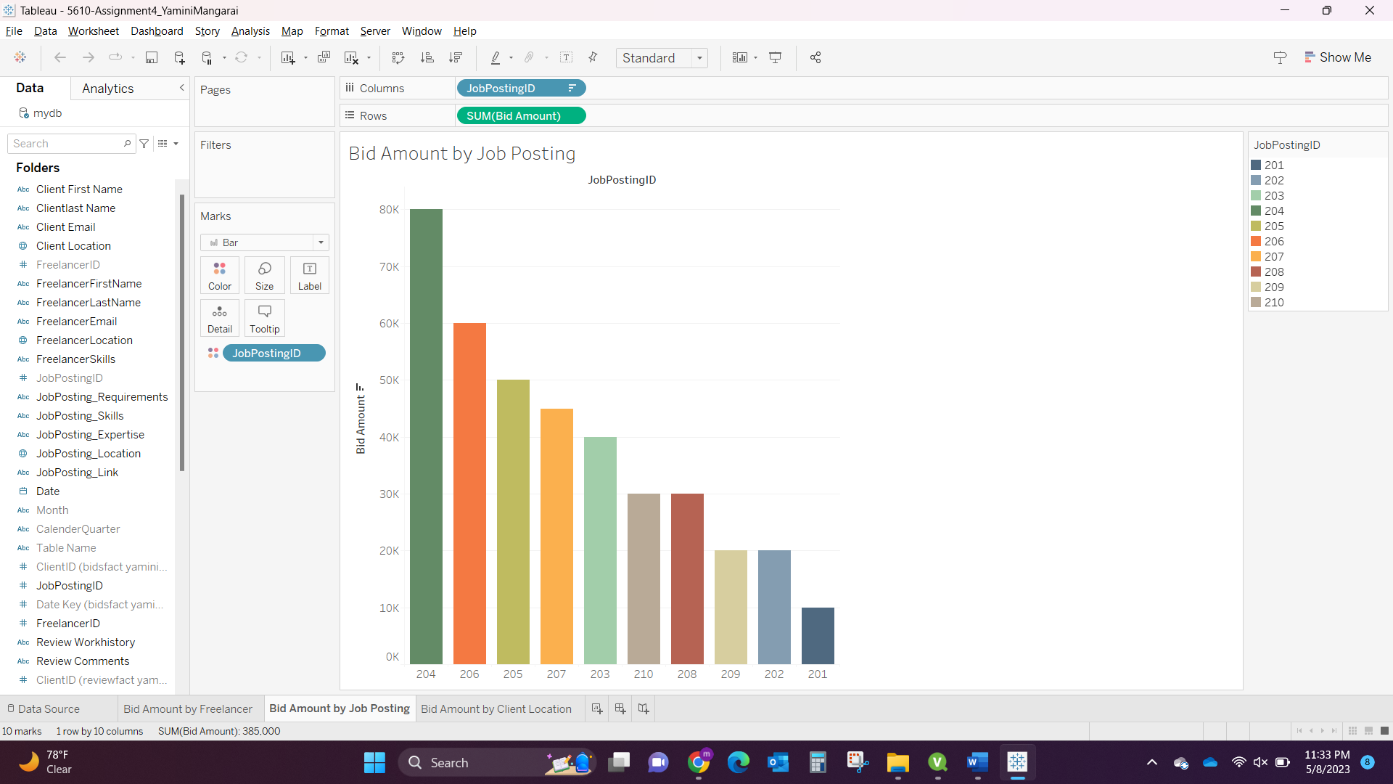

1. Bid Amount by Client Location: The result shows Correct as Client Location Texas have highest Bid Amount 110K.

